**DESIGN AND IMPLEMENTATION OF A COLLABORATIVE ACADEMIC PLATFORM FOR COMPUTER SCIENCE STUDENTS WITH INTER-UNIVERSITY LEADER BOARD COMPETITIONS**

BY

**EBEATU** , Christos Sochinenyenwa

BU/22C/IT/7789

DEPARTMENT OF COMPUTER SCIENCE

BAZE UNIVERSITY

ABUJA

SEPTEMBER, 2025

**Design And Implementation of a Collaborative Academic Platform for Computer Science Students with Inter-University Leader Board Competitions**

**Project Submitted in Partial Fulfillment of the Requirement for the Degree of**

**B. Sc.**

**In**

**Computer Science**

**By**

**EBEATU,** Christos Sochinenyenwa

To

The Department of Computer Science

Baze University, Abuja

**September, 2025**

# DECLARATION

I hereby declare that this project entitled “**Design And Implementation of a Collaborative Academic Platform for Computer Science Students with Inter-University Leader Board Competitions**”was carried out by me under the supervision of Dr. Usman Bello Abubakar. The work has not been presented in any previous work for the award of a BSc degree to the best of my knowledge. The work is entirely mine and I accept the sole responsibility for any error that might be found in the work, while the reference to published material have been duly acknowledged.

__________________________ _____________________

Christos Sochinenyenwa Ebeatu Date

BU/22C/IT/7789

**APPROVED BY**

_____________________

**Head of Department,**

Department of Computer Science

# CERTIFICATION

This is to certify that this project entitled **“Design And Implementation of a Collaborative Academic Platform for Computer Science Students with Inter-University Leader Board Competitions”**, being submitted by Ebeatu, Christos Sochinenyenwa in partial fulfilment of the requirement for the award of degree for B.Sc. in Computer Science to the Department of Computer Science, Baze University Abuja, Nigeria is a record of the candidate’s own work carried out by the candidate under my supervision. The matter embodied in this project is original and has not been submitted for the award of any other degree.

__________________________ _____________________

Date Dr Usman Bello Abubakar

# APPROVAL

This is to certify that this project entitled, **Design And Implementation of a Collaborative Academic Platform for Computer Science Students with Inter-University Leader Board Competitions** by **Ebeatu, Christos Sochinenyenwa** with BU/22C/IT/7789 has been approved by the Department of Computer Science, Faculty of Computing and Applied Science, Baze University, Abuja, Nigeria.

By

----------------------- -----------------------

Dr Usman Bello Abubakar Date/Sign

Supervisor

----------------------- -----------------------

Dr. Usman Idris Abubakar Date/Sign

Head, Department of Computer Sciences

----------------------- -----------------------

Prof. Aliyu Rufai Date/Sign

Dean, Faculty of Computing and Applied Science

----------------------- -----------------------

External Examiner Date/Sign

# DEDICATION

I dedicate this work to my family and friends who constantly encourage and motivate me to be my best. To my mentors who have guided me to my destined path in life. And last but not least. To myself for always showing up and putting in the work. Thank you all for your unwavering support throughout my life.

# ACKNOWLEDGMENT

My acknowledgement goes to my loving family for their never-ending love and support throughout my life. Special thanks to the lecturers and members of the computer science department and faculty for imparting in me most of the knowledge I have and for pushing me to be greater. To my supervisor, Dr. Usman Abubakar Bello, thank you for making this process smooth and for guiding me at every step of the way. I recognize and appreciate your effort. Lastly, I would like to acknowledge myself for never giving up even in the face of challenges.

Thank you all.

# ABSTRACT

The utilization of technology in education has provided Nigerian students with platforms that aid knowledge sharing, assessment, and collaboration. However, most existing platforms being used in Nigerian schools are fragmented, focusing either on exam preparation or quiz-based learning, without integrating features that foster collaboration among university students and encourage healthy academic competitions. This study analyzes gaps, reviewing platforms such as Google Classroom, Moodle, Kahoot, ulesson,and MySchool.ng. Based on the analysis, a Collaborative Academic Platform for Computer Science Students with Inter-University Leader Board Competitions is developed and implemented using Next.js and MongoDB. The web application combines academic material sharing, quizzes, gamification features such as leaderboards, and inter-university competitions. Adopting this system will increase the performance and participation of computer science students, and foster collaboration across Nigerian universities.

**TABLE OF CONTENTS**

DECLARATION iii

CERTIFICATION iv

APPROVAL v

DEDICATION vi

ACKNOWLEDGMENT vii

ABSTRACT viii

LIST OF TABLES xi

LIST OF FIGURES xiii

CHAPTER 1 1

INTRODUCTION 1

1.1 Background to the Study 1

1.2 Statement of the Problem 1

1.3 Aim and Objectives 2

1.4 Scope of the Project 3

1.5 Limitations of the Project 3

1.6 Significance of the Project 3

1.7 Project Risk 4

1.8 Swot Analysis 4

1.9 Organization of the Project 6

CHAPTER 2 6

LITERATURE REVIEW 6

2.1 Introduction 6

2.2 Historical Overview 7

2.2.1 Precolonial Education in Nigeria 7

2.2.2 Colonial Education Era 8

2.2.3 Education in Post-Independence Nigeria: Policies, Examinations, and the Past Questions Culture 9

2.2.4 Introduction of ICT and Ed Tech in Nigerian Schools 10

2.3 Thematic Review 12

2.3.1 Collaborative Learning in Higher Education 12

2.3.2 Gamification in Education 14

2.3.3 Online Quizzes and Assessments 16

2.3.4 Academic Competitions and Motivation 17

2.4 Related Works 18

2.4.1 Evaluation of Online Learning Systems 18

2.4.2 Evaluation of Nigerian Based Online Learning Systems 23

2.5 Summary 26

CHAPTER 3 31

REQUIREMENTS, ANALYSIS, AND DESIGN 31

3.1 Overview 32

3.2 Adopted Methodology 32

3.3 Tools and Techniques 33

3.4 Requirements Analysis 33

3.4.1 Functional Requirements Specifications 33

3.4.1 Non-Functional Requirements Specifications 35

3.5 System Design 36

3.5.1 Application Architecture 36

3.5.2 Use Case Diagram 37

3.5.3 Entity Relationship Diagram 46

3.5.4 Activity Diagrams 46

3.5.5 Dataflow Diagram 49

3.5.6 Control Flow Diagram 50

3.5.7 User Interface Design 51

3.6 Summary 54

CHAPTER 4 55

IMPLEMENTATION AND TESTING 55

4.1 Overview 55

4.2 Main Features 55

4.3 Implementation Problems 56

4.4 Overcoming Implementation Problems 56

4.5 Testing 57

4.6 User Guide 66

4.7 User Interface Design 67

4.8 Summary 75

CHAPTER 5 76

DISCUSSION, CONCLUSION, AND RECOMMENDATIONS 76

5.1 Overview 76

5.2 Objective Assessment 76

5.3 Limitations and challenges 76

5.4 Future Enhancement 77

REFERENCES 78

APPENDICES 85

# 

# LIST OF TABLES

Table 1.1: Risk Assessment ...........................................................................…….4

Table 1.2: SWOT Analysis .............................................................................……5

Table 2.1: Related works summary .......................................................................27

Table 3.1: Functional requirements of the students ..............................................34

Table 3.2: Functional requirements of the admin .............................................…34

Table 3.3: Non-Functional requirements ..........................................................…35

Table 3.4: Use-Case Description for Register .......................................................39

Table 3.5: Use-Case Description for Login ..........................................................40

Table 3.6: Use Case Description for Material upload ...........................................41

Table 3.7: Use Case Description for Quiz Taking ................................................42

Table 3.8: Use-Case Description for Quiz Creation ........................................….43

Table 3.9: Use-Case Description for Approval/Rejection of Materials ................43

Table 3.10: Use Case Description for Viewing Materials ...............................….44

Table 3.11: Use Case Description for Viewing Leaderboard ..........................…45

Table 4.1: Testing for User Registration ..............................................................57

Table 4.2: Testing for User Login .......................................................................58

Table 4.3: Testing for View Users .......................................................................59

Table 4.4: Testing for Create Quiz ......................................................................59

Table 4.5: Testing for Materials Approve/Reject .................................................60

Table 4.6: Testing for View Leaderboard (Admin) ...........................................61

Table 4.7: Testing for View Materials .................................................................62

Table 4.8: Testing for Upload Materials ...............................................................63

Table 4.9: Testing for Taking Quiz ......................................................................64

Table 4.10: Testing for View Leaderboard (Student) ...........................................65

# LIST OF FIGURES

Figure 2.1: User Interface of Moodle ....................................................................20

Figure 2.2: User Interface of Google Classroom ..................................................21

Figure 2.3: User Interface of Google Classroom ..............................................…21

Figure 2.4: User Interface of Kahoot! ..............................................................….23

Figure 2.5: User Interface of Myschool.ng .......................................................…24

Figure 2.6: User Interface of Myschool.ng ...........................................................25

Figure 2.7: User Interface of ULesson ..................................................................26

Figure 2.8: User Interface of ULesson ..................................................................26

Figure 3.1: Incremental Model………………. .....................................................32

Figure 3.2: Application Architecture Diagram .....................................................37

Figure 3.3: Use Case Diagram .........................................................................….38

Figure 3.4: Entity Relationship Diagram ..............................................................46

Figure 3.5: Login Activity Diagram .....................................................................47

Figure 3.6: Upload Material Activity Diagram (Student) .....................................48

Figure 3.7: Approve/Reject Material Activity Diagram (Administrator) .............49

Figure 3.8: Quiz Taking Activity Diagram (Student) ......................................….49

Figure 3.9: Quiz Creation Activity Diagram (Administrator) ..............................49

Figure 3.10: View Leaderboard Activity Diagram ...............................................49

Figure 3.11: Dataflow Diagram ........................................................................…50

Figure 3.12: Control Flow Diagram for Students ............................................….50

Figure 3.13: Control Flow Diagram for Administrators .......................................51

Figure 3.14: Registration Page .......................................................................…..51

Figure 3.15: Admin Dashboard .........................................................................…52

Figure 3.16: Login page .............................................................................……...52

Figure 3.17: Student dashboard .......................................................................….53

Figure 3.18: Available Quizzes page (student) ................................................…53

Figure 3.19: View Materials page (student) ..........................................................54

Figure 4.1: Home page ................................................................................……..67

Figure 4.2: Registration Page ........................................................................……68

Figure 4.3: Login page ...............................................................................……...68

Figure 4.4: Admin Dashboard ..........................................................................….69

Figure 4.5: User management page (admin) .........................................................69

Figure 4.6: Pending Materials page (admin) .........................................................70

Figure 4.7: Quiz management page (admin) .........................................................70

Figure 4.8: Leaderboard management page (admin) ............................................71

Figure 4.10: View Materials page (student) .....................................................…71

Figure 4.11: Upload Materials page (student) .......................................................72

Figure 4.12: Available Quizzes page (student) .....................................................72

Figure 4.13: Quiz taking page (student) ............................................................…73

Figure 4.14: Quiz results page (student) ...............................................................73

Figure 4.15: Leaderboard page (student) ..............................................................74

Figure 4.16: Student dashboard ........................................................................…74

**CHAPTER 1**

**INTRODUCTION**

**1.1 Background to the Study**

Collaborative learning in an academic environment involves participating in discussions, problem-solving, and studying in groups (The University of Queensland, Australia, n.d.). The bedrock of this learning approach is shared knowledge. In higher education, creating a space where learners can share ideas, questions, and teaching materials regardless of their skills and abilities ensures that they are properly engaging with new information and contributing to the learning process.

Education is being revolutionized through the use of technology, (Herrera-Pavo, 2020) stated that Information and Communication Technologies (ICTs) favour collaboration in a learning situation. It is important to move on from a teaching system that embraces a traditional pedagogical approach, which leaves students with little space to think, as the teacher is the centre of the student-teacher relationship (Hu, 2024). With peer-to-peer interaction, there is a parallel relationship rather than a vertical one, and this makes students feel comfortable seeking support and challenging themselves academically.

However, many Nigerian computer science students struggle to access quality course materials outside of their respective universities. Their learning is often limited because access to past questions, lecture notes, and peer assistance is only dependent on their personal network. This project aims to fill this gap by providing a platform where students across Nigerian universities can share and access course materials, practice with quizzes, and participate in inter-university competitions. The platform encourages collaboration and student engagement.

**1.2 Statement of the Problem**

In most Nigerian universities, 15-30% of the infrastructure and equipment used is outdated (Garba, 2023). These infrastructures include, but are not limited to, online learning platforms, libraries with physical and digital resources, research, and academic support services. Students often rely on decentralized networks confined within their universities such as class groups or departmental associations for knowledge exchange. The lack of collaboration among universities can weaken knowledge communities and reduce opportunities for peer learning.

Additionally, there's little emphasis when it comes to fostering healthy competition between students in different universities. Competitions are capable of motivating students to participate actively during learning and it also sharpens their problem-solving skills. Despite this, most learning platforms skip out on implementing competitive features or keep them confined to institutional boundaries. Therefore, not engaging students in competitions which allow them to learn while dealing with real challenges creates a gap in the necessary skills and knowledge they should have acquired.

Without a centralized platform where students can share knowledge from diverse perspectives and participate in quizzes and competitions, many students are left feeling discouraged and you end up with a learning experience that feels disjointed.

**1.3 Aim and Objectives**

This study aims to design and implement an collaborative academic platform for computer science students with inter-university leader board competitions

Objectives:

1. To create a user interface where computer science students across Nigerian universities can share and access academic materials.
2. To implement a quiz creation module for making quizzes and academic competitions that students can participate in.

3. To provide an efficient user management system that allows administrators to oversee student activities, monitor their performance, and evaluate engagement for continuous platform improvement.

4. To implement a leaderboard ranking system for academic competitions across institutions.

**1.4 Scope of the Project**

The scope of this project is to create a platform where computer science students from any Nigerian University can share information and materials, and participate in competitions/quizzes to be ranked on a leaderboard.

The system will be developed as a web-based application that can be accessed on major web browsers. It will be built using Next.JS and the database will be managed using MongoDb. This project is focused on delivering a functional MVP (Minimum Viable Product) that ensures structure, usability, and collaboration.

**1.5 Limitations of the Project**

The limitations of this project are:

1. The platform will not provide robust learning progress analytics for each user.
2. Stable internet connection is required to use the platform.
3. Limited academic material and quiz database at the beginning stages.
4. Due to the novelty of the system, it may take time to attract users across universities.
5. It does not provide a discussion forum for students to form connections and share ideas.

**1.6 Significance of the Project**

The purpose of this project is to identify the need for a centralized area where computer science students are able to share knowledge materials with their peers regardless of location and test their abilities. The importance of peer-to-peer learning is constantly being highlighted, and with the boom of education technology in the past 5 years, this platform will create a modern approach to learning.

Additionally, giving users the means to upload and access lecture notes, past questions, and relevant study material provides them with tools for learning, understanding, and preparing for tests and examinations. They can then proceed to test their knowledge by taking quizzes that assess them on computer science related areas or participate in competitions to be ranked individually on the leaderboard.

These features motivate them and ensure that the users are actively involved during learning because it is centred on the students' participation, which encourages education beyond the traditional classroom setting.

This platform has broader implications for Nigerian higher education by breaking down institutional silos and creating a unified learning ecosystem. Universities can benefit from increased student engagement and cross-institutional knowledge transfer, while the education system gains a scalable solution to address infrastructure limitations identified in the problem statement.

**1.7 Project Risk**

**Table 1.1: Risk Assessment**

|  |  |  |
| --- | --- | --- |
| RISK DESCRIPTION | MITIGATION | IMPACT |
| Students on the platform are inactive e.g. low participation in competitions, no conversations in the discussion forum etc. | Add gamification such as point system, challenges, and leader-boards to encourage healthy competition and participation. | High |
| Users uploading inappropriate content | Implement an admin panel that reviews all content and a flagging system that detects and flags suspicious activity. | High |
| Difficulty verifying students from multiple universities | Users should be required to upload their valid school identification cards for verification | High |
| Scalability issues from growing number of users and contents which may affect system performance. | Use efficient database structure, pagination, and content-based indexing | High |
| Timeline may be too short to complete all the features | Prioritize a MVP | Medium |

**1.8 Swot Analysis**

**Table 1.2: SWOT Analysis**

|  |  |
| --- | --- |
| **STRENGTHS** | **WEAKNESSES** |
| Encourages students to engage with their peers and learn from them  Connects students all over the country  Promotes learning and healthy competition through gamification (i.e. challenges, leaderboard) | Initial users may not have enough content to leverage because more users are yet to join to upload materials and start discussions  The subjective opinion and sources of knowledge of many users from multiple schools may lead to misinformation  quizzes and challenges that are not multiple choice questions have to be manually reviewed which may cause delays in grading |
| **OPPORTUNITIES** | **THREATS** |
| It can be expanded to accommodate other education levels (i.e. Junior Secondary School, Senior Secondary School)  Users at the top of the leader-board could stand a chance to win physical rewards. It will encourage them to join competitions and work hard.  Collaborating with universities to increase student adoption. | Users in areas with bad network may not have steady access to the platform  Harmful and inappropriate content may be uploaded putting other users at risk.  Competition from other Edtech companies  User data like login info may be at risk. |

**1.9 Organization of the Project**

Chapter 1: Introduction

Overview of the project, including background, objectives, problem statement, and risk assessment.

Chapter 2: Literature Review

It explores related works and limitations in existing online collaborative academic platforms.

Chapter 3: Methodology

This chapter covers the system requirements, system architecture, and the design approach.

Chapter 4: Implementation and Testing

Details the application development and testing process. Outlines the tools, framework, and test cases during implementation.

Chapter 5: Conclusion

Summarises the project, key findings, and suggestions for future improvement.

**CHAPTER 2**

**LITERATURE REVIEW**

* 1. **Introduction**

This chapter talks about past works and existing body of research relevant to the development of this project. It reviews theoretical and thematic findings from previous studies on collaborative learning, gamification in education, academic competitions, and the use of digital learning platforms in Nigerian universities. This chapter will also analyze related systems, both globally and within Nigeria , highlighting their features, strengths, and limitations.

**2.2 Historical Overview**

**2.2.1 Precolonial Education in Nigeria**

In precolonial Nigeria, education was not confined to a formal school setting like it is today. To fully understand the development of education and technology in Nigeria, it is important to first examine how knowledge was transmitted in the precolonial era. Education at this time involved the individual and their society. It was believed that engaging in community projects developed well rounded individuals and fostered cooperation among the people (Ogunlola, 2020). Before the introduction of foreign ideals, there was major emphasis on moral education because it was regarded as a major catalyst for societal growth. They used folklore, proverbs, tales etc. to teach moral values and pass on cultural values and traditions.

Many Nigerian ethnicities operated the apprentice system. (Nnonyelu & Onyeizugbe, 2020) referred to an apprentice as a person who has agreed to submit himself/herself within a period of time under the tutelage of a master/mistress, with the aim of acquiring practical, hands on, experience, and mastering the nitty-gritty of a trade, vocation or profession. They employed apprenticeship to keep the youth from being idle and to propagate their expectation of a promising future where everybody can provide a livelihood for himself or herself. Skills in commerce, brick laying, welding, painting, vulcanisers, barbing, fashion designing, blacksmithing, mechanics or car/bicycle repairs, were passed down from master to apprentice. The apprentice will then be observed by the master to assess their readiness.

Thus, education was holistic, preparing the individual for moral uprightness and practical livelihood. However, this indigenous system of education was later disrupted with the coming of colonialism and the introduction of Western formal schooling.

**2.2.2 Colonial Education Era**

Western Education was introduced by British Christian missionaries, establishing the first primary school in Nigeria in the 1840s (Evgeniou, 2022). They prioritized teaching biblical and English history in order to celebrate the imperial agenda while disregarding African history and culture before the Europeans. The lack of focus on indigenous education like the vernacular and cultural history prompted the early educated Nigerian elites to challenge these colonial policies. (Akanbi & Jekayinfa, 2021).

The 1882 Education Ordinance was the first education policy crafted by the British government for the establishment of a General Board of Education to build new schools in villages, certify teachers, and determine schools eligibility for government grants. The policy designed a curriculum for formal education focused solely on reading, writing, arithmetic, religion, English language and needle work for girls (Ofobuike, 2025). The 1948 education act prepared for the establishment of higher education institutions in Nigeria, as before that emphasis was placed on primary and secondary schools (Ofobuike, 2025).

In addition to shaping the curriculum and school structure, the colonial masters also dictated how knowledge was assessed. Nigerian students would sit for examinations that were tailored to the British, providing little to no benefit to the indigenous people. These examinations would be set by the London University School Examinations and Matriculation Council; University of Cambridge Local Examinations Syndicate; the London Chamber of Commerce; The Royal Society of Arts (RSA) and The City and Guilds of London Institute (Anyanwu, 2023).

Thus, the colonial education era not only made indigenous culture insignificant in education, but also created a dependency on foreign curricula which continues to shape the post-colonial education policies.

**2.2.3 Education in Post-Independence Nigeria: Policies, Examinations, and the Past Questions Culture**

After Nigeria gained its independence in 1960, its crucial task became creating a solid foundation for future prosperity of the nation. They aimed to use the education policy to nurture educated individuals in the society and build a thriving economy. It was the inadequacies of the previous policy that brought about the 1969 National Conference. The conference was a necessary step toward educational emancipation. Academic institutions, local governments, trade unions among others expressed their dissatisfaction with the existing educational system and called for a review and reform of the national goals for education in Nigeria at all levels (Okparaugo et al., 2021).

The conference led to the creation of the Nation Policy on Education (NPE) of 1977. The policy clearly stated the national goals of education, established the 6-3-3-4 education system (6 years primary, 3 years junior secondary, 3 years senior secondary, 4 years tertiary), and focused on integrating Nigerian culture into education.

At the same time, examinations became an equally powerful influence on the education system. In 1952, the West African Examination Council (WAEC) was established and its first examination was conducted under the name Public Service Executive Competitive Examination (Anyanwu, 2023). Due to this development, Nigerian students became increasingly reliant on past examination question papers (PEPQs) to prepare for upcoming examinations. Most students use PEPQs as a way to test themselves before the examination. It has become so common for candidates to seek out PEPQs for national examinations like West African Examination Council (WAEC), Universities and Tertiary Matriculation Examination (UTME) conducted by the Joint Admission and Matriculation Board (JAMB), and even internal tests organized by tertiary institutions (Umuerhi & Urhiewhu, 2023). This practice emerged because students noticed recurring patterns in the examinations. It allowed students to be able to predict possible questions, therefore they studied inline with previous questions.

Noticing the demand, PEPQs were compiled into exam guide booklets and were sold to schools and students across all levels of education. Students were able to find gaps in their knowledge, and practice under improvised examination conditions, but it also reinforced the mindset that passing examinations meant being educated. As a result, teaching and learning became focused on memorization instead of understanding, and values high performance in tests rather than problem solving and critical thinking skills.

**2.2.4 Introduction of ICT and Ed Tech in Nigerian Schools**

Daramola and Aladesusi (2022) defined Information Communication Technologies (ICT) as electronic technologies used for information storage and retrieval. ICT is becoming an integral part of education at all levels. It has played a major role in enhancing learning and improving students’ ability to understand and retain information (Rani et al., 2023). It was crucial that Nigeria kept up with the global adoption of ICT in education in order to modernize it.

Computer Education was first issued in 1988 and teachers who were not professionally experienced would teach with unapproved documents or self-compiled topics until computer education was made a compulsory subject in primary and junior secondary schools, and a curriculum was designed for it in 2004 and 2002 respectively (Tshukudu et al., 2023). The curriculum covered the basic concepts and applications of ICT in the primary level and basic computer operations, computer hardware, and software in secondary level.

ICT has reshaped the pedagogical approach. Twahirwa et al. (2021) indicate the failure of traditional teaching methods to engage learners, leading to passive learning, which in turn conveys surface knowledge. Many schools across the country are gradually replacing restrictive tools like textbooks, blackboards, and chalk with multimedia tools such as Smart Boards, which can make learning more dynamic, collaborative, and engaging (Olugbade et al., 2023).

Furthermore, the application of ICT in library access and management is necessary for enhancing the accessibility of information from different electronic devices. University libraries are fully involved in improving the digitization, dissemination, and preservation of academic resources like textbooks, lecture notes, research papers, past questions, and so on. Digital libraries can enable students’ immediate access and active participation with digital academic resources (Igbo et al., 2022).

In addition to ICT being introduced in various aspects of learning, it was also used as a method of testing, also known as ‘E-testing’ or ‘Computer-Based Test’ (CBT). Computer-based testing is a method of using computers to administer assessments. In 2015, Unified Tertiary Matriculation Examinations (UTME) was written using computer-based technology, marking the beginning of CBT in Nigeria (Buoye & Bada, 2021).

**2.2.4.1 Rise of EdTech Platforms**

Education Technology (EdTech) is the effective use of technology tools in learning. It combines the use of software, hardware, education, and learning. Any technology-related tool that facilitates learning and research is referred to as EdTech (Oshodi, 2022). Examples of EdTech include: educational apps, gamification, virtual classrooms, learning management systems, artificial intelligence, and Interactive Smart Boards (ISB).

The rapid increase in demand for technological advancements has given rise to EdTech entrepreneurship in Nigeria. EdTech aims to provide innovative solutions in the educational sector through the development of new technologies.

Nigerian EdTech startups include but are not limited to:

1. uLesson - an online education platform that provides interactive courses for various subjects.
2. Edukoya - connects African learners with the best teachers—on-demand tutors.
3. Tuteria Limited - provides personalized lessons from verified tutors.
4. Pass.ng - simulates examinations to test students and prepare them for national examinations.

Digital platforms like these are essential for improving learners’ performance and understanding outside the formal classroom. They offer features like online quizzes, gamified learning, and engaging learning experiences.

Although the benefits of adopting EdTech are undeniable, significant challenges persist. Issues such as low bandwidth in rural areas, high cost of mobile devices such as tablets or laptops, and lack of willingness of teachers to adopt technology (Patil et al., 2024). The COVID-19 pandemic further revealed the importance of technology-driven solutions in ensuring learning activities were efficient and accessible (Ebohon et al., 2021). Today, ICT and EdTech are increasingly recognized as essential tools for access and inclusivity in Nigeria's education system.

**2.3 Thematic Review**

**2.3.1 Collaborative Learning in Higher Education**

Collaborative learning is an educational approach where two or more students work together in a coordinated, synchronous activity to maintain a shared understanding of a problem and to provide solutions to that problem. Qureshi et al. (2021) describe it as a powerful method of active learning, where students participate and interact in group environments to manage relationships and develop content. This process integrates students into communities where they can share knowledge and develop a deeper understanding of a specific area. Members of these knowledge communities depend on each other's expertise to build collective cognizance, extending beyond the individuals capacity and knowledge.

Studies have shown that peer interaction leads to a successful collaborative learning, as it improves students' interest , helps them explore different ideas, and enhances their learning outcomes (Qureshi et al., 2021). In these interactive environments, students serve as learning mediums for each other by talking, observing others' work, and sharing information. As noted by Yusof et al. (2022), Social Network Systems (SNS) like Facebook, WhatsApp, and Telegram have become vital tools for facilitating collaborative learning and fostering peer learning skills, by allowing students to build a social network of like minded people, share ideas, and engage in group discussions. Lipponen (2023) suggests that these digital tools can enhance peer interaction, facilitate the sharing of knowledge among community members, and break down the physical and temporal barriers of traditional pedagogy.

A study by Tolorunleke et al. (2023) in Kogi State, Nigeria, found that WhatsApp was used by all 370 student respondents for learning, with Facebook, Twitter, and YouTube also being popularly utilized for collaborative learning. Regardless of the availability of these tools, students tend to use them primarily for entertainment purposes, rarely exploring its effectiveness in teaching and learning. The popularity of these online tools among Nigerian students have brought up a need to supplement conventional learning methods with digital ones in order to simulate students' interest and improve academic performance.

The success of collaborative learning can be reduced by several challenges. Kerman et al. (2023) highlight the lack of trust in peers' competence to provide high-quality contributions, as students may be sceptical about their peers being sufficiently educated on a topic. The issue of trust can also be related to a phenomenon Boud & Bearman (2022) call ‘*freeloading*’, which is compounded by uneven participation, where some group members contribute significantly more than others. Furthermore, certain infrastructural barriers, such as poor internet connectivity and lack of devices, can impede digital learning, especially for students that reside in rural areas(Yusof et al., 2022). The social dynamics of peer interactions can also be complex; Sridharan et al. (2023) found that issues like fear of disapproval, social pressure, and discomfort in marking peers can negatively impact honest assessment.

Digital platforms can directly address these challenges by creating a trusted, structured academic space that facilitates organized collaboration. Such platforms help expand student interaction beyond informal social networks like WhatsApp and group chats limited to a particular university. Features like anonymity can reduce social pressure and foster more objective feedback (Sridharan et al., 2023; Topping, 2023), while structured tools can enhance the quality and fairness of peer contributions, thereby building the trust that Boud and Bearman (2022) and Kerman et al. (2023) identify as central to productive collaboration.

**2.3.2 Gamification in Education**

Gamification is the process of applying game-like elements and mechanics to non-game contexts, such as the classroom, to engage people, stimulate action, promote learning, and solve problems (Kapp, 2012, as cited in Sabornido et al., 2022; Nwachukwu & Johnson, 2020). The core idea is to transform conventional learning tasks into interactive and enjoyable activities, thereby creating attractive experiences that arouse curiosity and capture students’ attention. It is however different from Game-Based learning (GBL) which is when a complete game is used to teach. The aim of gamification is to make the learning process more enjoyable and interactive; thereby motivating students and increasing their engagement with the academic material(Adeoye, 2023).

Integrating game mechanics has become increasingly widespread. A comprehensive meta-analysis of 22 experimental studies confirmed that gamification has a moderately positive overall effect on student academic performance (Zeng et al., 2024). The most common gaming elements incorporated in learning are points, badges, and leaderboards. These components serve a distinct psychological function, for example, points provide immediate feedback after an achievement; badges act as visual representations of progress; and leaderboards foster a sense of healthy competition by allowing students to see their performance compared to their peers (Adeoye, 2023; Iji-Okeke & Okeke, n.d.). Together, these elements encourage active participation and can help sustain student engagement over time. Integrating gamification has been shown to help students grasp difficult concepts and deepen their understanding. The positive impact is clear in a three-year longitudinal study, which found that a gamified course yielded significantly better outcomes in student success, excellence, and retention rates compared to both traditional and online formats (Lampropoulos & Sidiropoulos, 2024).

This need for innovative pedagogy is particularly acute in the Nigerian context, where conventional teaching methods are often perceived as unappealing to a diverse, technology-oriented generation of learners (Iji-Okeke & Okeke, n.d.). Nigerian universities are often met with a large number of students each from diverse cultural backgrounds and with varying proficiency, which makes differentiated instruction a significant challenge. By utilizing gaming mechanics, a student's learning process takes place at their own pace and provides personalised and adaptive experiences. For instance, a study at the Federal University of Education, Zaria, found that using the platform Kahoot! led to notable improvements in language proficiency, especially among lower-proficiency students, effectively helping to narrow the achievement gap (Balogun, n.d.). Similarly, another Nigerian study demonstrated that a gamified activity significantly enhanced college students' achievement in Number Systems (Okekeokosisi et al., 2025). But due to some infrastructural issues: inconsistent internet connectivity, limited access to technological devices, implementation is being restricted to few parts of Nigeria.

However, the implementation of gamification is not a universal solution and comes with its own set of challenges. One of the primary risks is an overemphasis on competition, which can be detrimental if not managed correctly (Iji-Okeke & Okeke, n.d.). A systematic review of these barriers revealed several critical issues: not all students are fully engaged by gamification, some find that it creates an excessive workload, and it may not appeal to certain personalities or learning styles (Sabornido et al., 2022). Therefore, an ineffective strategy when adopting gamified learning can negatively impact learning outcomes and lead to students becoming frustrated down the line. For example, the complex combination of certain elements, such as Levels, Awards, Badges, and Leaderboards, were actually found to have a negative effect on academic performance, serving as a caution against adopting multiple elements without a clear pedagogical strategy (Zeng et al., 2024).

Recognising both the potential and the pitfalls is therefore crucial for designing gamified experiences and applications that are balanced and purposeful. The leaderboards and quizzes in my collaborative platform are designed to encourage healthy competition among diverse learners, rather than creating a high-pressure environment. This approach aligns with research suggesting that elements like leaderboards can promote positive learning outcomes when they foster a supportive atmosphere (Ezzeh, 2025, as cited in Okekeokosisi et al., 2025). By doing so, the goal is to motivate students through immediate feedback and a sense of achievement, turning learning into an intrinsically engaging and interactive experience (Iji-Okeke & Okeke, n.d.).

**2.3.3 Online Quizzes and Assessments**

Online quizzes and assessment tools have transformed how formative assessments are carried out. It offers students the ability to test their understanding and engage in self-paced-paced practice tests. Online quizzes are an essential component of e-learning for testing learners and providing immediate feedback in most cases. The COVID-19 era accelerated the adoption of these technologies that were being used for assessments and measuring learning outcomes during widespread international closures (Simelane & Pillay, 2024). Platforms like Moodle and Google Forms have become a staple in most tertiary institutions, because it allows instructors to deliver and analyze assessments stress-free. Research indicates that students value e-assessment for its easily accessible and fast feedback, which in turn increases their motivation (Shalatska et al., 2020)

The use of online quizzes as a formative assessment tool has been shown to improve student engagement and academic performance (Chen et al., 2021). A study by Morris et al., (2021) found that students perform better on final exams when they engage in online tests and receive immediate feedback. These low-stakes assessments promote active recall and strengthen long term memory for storing academic information. Compared to traditional high-stakes exams, where everything is on the line, the online tools are adaptable to an individual's level of knowledge, helping lecturers monitor students progress and provide timely and personalized feedback (Simelane & Pillay, 2024).

During the COVID-19 pandemic many Nigerian Universities were forced to use e-learning tools such as: Google Classroom, Microsoft teams, and Zoom, and despite these tools being implemented at the time many institutions still face significant issues with fully transitioning from the usual ways of assessing students to e-assessment methods. One issue they face is the digital divide, where disparities in access to stable internet connection and lack of access to suitable devices can create an environment where certain students are not able to perform fairly in online assessments (Ibrahim et al., 2023; Okoroafor, 2020, as cited in Ibrahim et al., 2023). Another concern with adopting online testing is maintaining academic honesty. The remote nature of these tests create opportunities for students to cheat (Simelane & Pillay, 2024). Due to the lack of integrity, instructors have adopted strategic methods for curbing this, such as setting questions that require critical thinking and problem solving skills, monitoring their activities with online tools (Özyer, 2024), and making sure that each student gets unique and varied tests from a randomized question bank (Sullivan, 2016). Furthermore, both students and educators may lack the necessary digital literacy to use these tools effectively, highlighting a need for continuous training and support (Mahlangu & Makwasha, 2023).Despite these obstacles, there is a need for mobile and user-friendly platforms that can make learning and assessment more accessible, and promote fair grading (James, 2022).

The quiz module in my platform aims to transform the way students study with past questions. By creating interactive quizzes from physical past questions, it ensures that students actively engage with the materials rather than memorizing with no basic comprehension. The feature of instant feedback leverages on one of the most valued aspects of online tools, promoting student continuous participation and self-paced learning. By making the assessment more efficient and data-driven, it empowers educators to better track a student's progress and adapt their teaching strategies (Shalatska et al., 2020), ultimately fostering a more dynamic and effective learning environment.

**2.3.4 Academic Competitions and Motivation**

Within tertiary institutions, competitions can arise both among universities looking for the best students for their programs, and among students themselves (Hart & Rodgers, 2024). Digital technology has popularized gamified competitions often integrating elements like leaderboards, a point system, and badges into educational settings. The aim is to get students to participate in academic activities causing a boost in student achievement and motivation. For example, studies on gamified mobile quizzing have confirmed their effectiveness in improving both engagement and academic performance.

In a study conducted with senior secondary school students in Lagos, Nigeria, researchers implemented a gamified biology application that featured leaderboards, badges, quizzes, and points. It revealed that incorporating these competitive and collaborative game mechanics improved students' engagement and attitude towards the subject (Udeani & Akhigbe, 2020). This research shows that gamified competitions in classrooms are effective for passing on knowledge onto Nigerian students.

Despite these benefits, excessive educational competitions can devalue creativity in solving problems and increase tension between the students. Also, when implementing a feature like the leaderboard it can perpetuate hierarchies which are detrimental to a proper learning environment with emphasis on understanding (Hart & Rodgers, 2024).

These insights collectively affirm the need for an online platform offering a structured and accessible way to implement proven game mechanics like leaderboards and challenges for Nigerian students. By accommodating both competitive and collaborative modes, such a platform would cater to diverse learning preferences while leveraging the synergistic power of these two dynamics. Ultimately, this platform could create a fair, constructive, and low-stakes environment to harness the motivational power of competition, making learning more engaging and effective for a broad student population in Nigeria

**2.4 Related Works**

This section reviews prior studies and systems related to collaborative learning, gamification, quiz platforms, and academic competitions. It highlights their contributions, limitations, and how this study intends to address existing gaps.

**2.4.1 Evaluation of Online Learning Systems**

**2.4.1.1 Moodle**

Moodle is an open source Learning Management System (LMS). It provides its users (educators and organizations) with a single, robust, secure, and integrated system to create personalized learning environments. It facilitates online training and learning.

Features

1. System administrators and course creators can build and manage courses.
2. Educators can create and manage assessments given to the learners.
3. Tracking a learner's progress by analyzing their activity, course completion and course reports.
4. Educators can reward learners with badges and certificates for achievements.

Strengths

1. Open source.
2. It is easy to use: Courses can easily be built by drag-and-drop and progress can be tracked.
3. Flexible and customizable: Organizations can configure the LMS with plugins or managed solution services to meet their requirements.
4. Compatible with various devices, including mobile phones and tablets.
5. Seamless integration with other learning or organizational platforms such as Microsoft teams, zoom etc.
6. Downloaded courses are available offline.

Limitations

1. Does not come with in-built gamification features like leaderboards and badges. The features have to be added with gamification plugins.
2. Does not support some types or sizes of course content.
3. Core functionality such as video conferencing requires plugins or extensions.

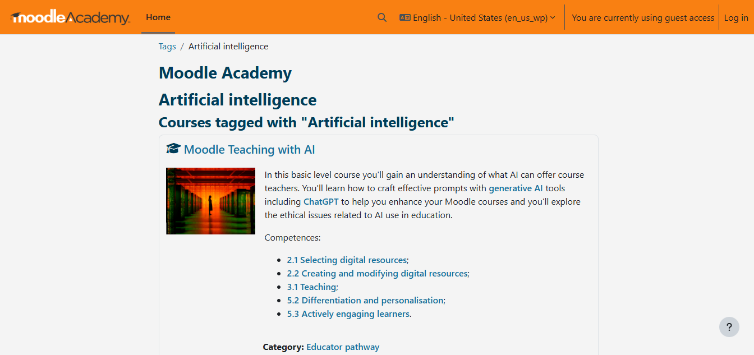

Figure 2.1 User Interface of Moodle

Overall, Moodle remains one of the most globally recognized LMS platforms, valued for its flexibility and open-source community. However, institutions with limited technical expertise may find reliance on plugins a challenge.

**2.4.1.2 Google Classroom**

Google Classrooms is a free cloud based platform used to manage digital classrooms. It is often used in educational institutions to create classrooms where information can be passed easily.

Features

1. It has a stream where teachers can post announcements and students can participate in question-driven discussion.
2. Teachers can create assignments, grade tasks and share academic material.
3. Students can view materials, turn in assignments, and collaborate with peers.
4. Teachers can invite students into their digital class.
5. The messaging feature allows teachers to leave comments on students' assignments.

Strengths

1. It is very user friendly.
2. Seamless integration with other Google tools like Google Drive, Google Docs, Google Sheets and Google Meet.
3. Push notifications and integration with Gmail keeps users updated on what's happening in the classroom.
4. Available on web browsers and mobile applications.

Limitations

1. Requires stable and consistent internet connection to use it.
2. It does not offer robust analytics or rubrics for monitoring a student's engagement and progress.
3. Limited integration with non-google platforms.
4. Does not include inbuilt gamification tools.

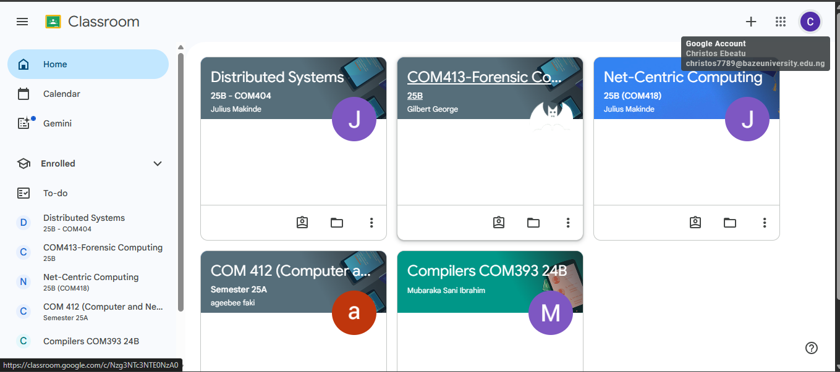

Figure 2.2 User Interface of Google Classroom

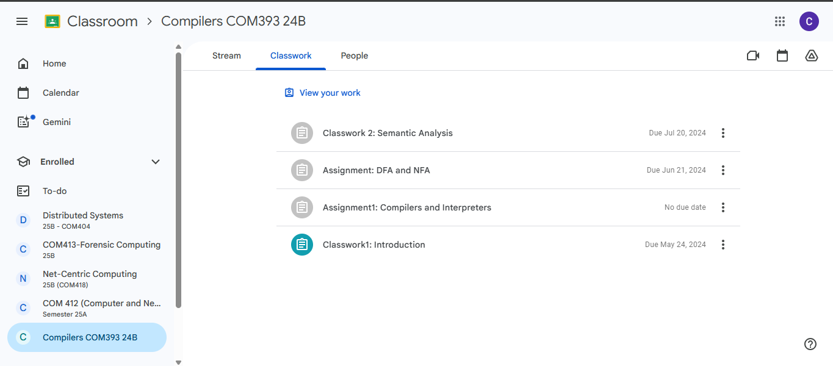

Figure 2.3 User Interface of Google Classroom

Google Classroom is highly effective for organizing and managing coursework in institutions already using Google’s ecosystem. However, its lack of advanced analytics and gamification limits its adaptability in more interactive learning contexts.

**2.4.1.3 Kahoot!**

Kahoot! is an online platform for hosting interactive trivia quizzes and knowledge based competitions. The games are known as “*kahoots*”, which are user-generated multiple-choice quizzes.

Features

1. Users create games (kahoots).
2. Host interactive sessions where users can answer questions on their own devices and the questions and answers are displayed on a shared screen.
3. Quizzes can be assigned to students to answer and they can be answered at their pace rather than having a set time.
4. Students can work in teams to complete challenges.
5. Quizzes are in various forms: multiple choice, true or false, puzzle, open-ended questions.
6. Instant feedback on polls and quizzes.

Strengths

1. Using gaming elements such as leaderboards, scoring systems, and timed answering to motivate students.
2. Accessible across various devices through web browsers or mobile applications.
3. Provides student progress tracking for teachers.

Limitations

1. Advanced features like detailed reports and integration require a paid subscription.
2. It focuses on short, quiz-based activities which may not be comprehensive enough for certain courses.
3. Content on the platform is user-generated bringing up concerns of quality, accuracy, and appropriateness.
4. Requires stable and consistent internet connection to use it.
5. Competitions can create a high pressure environment for students to perform exceptionally.

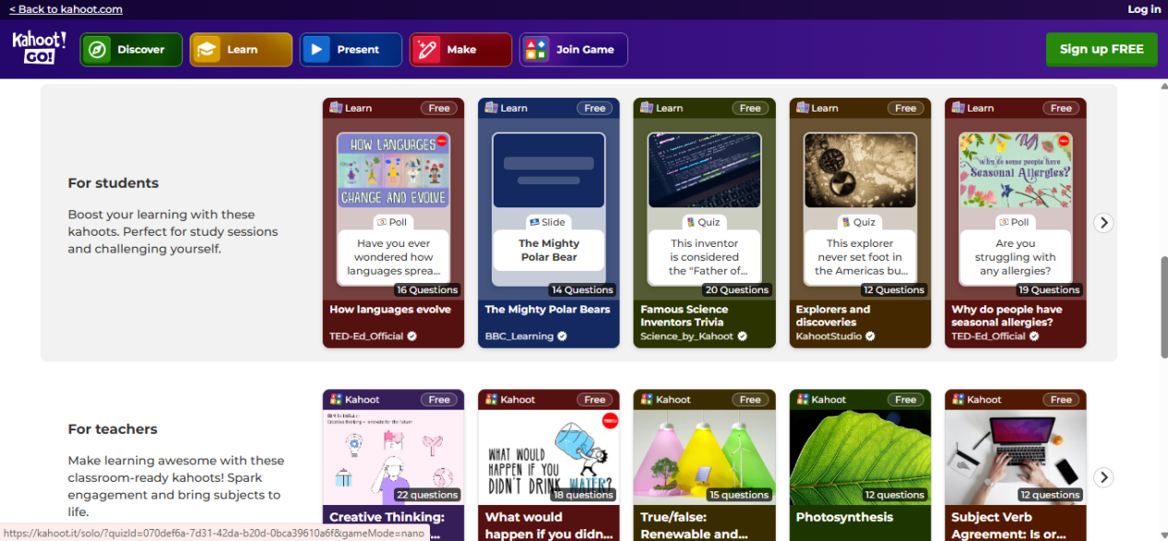

Figure 2.4 User Interface of Kahoot!

Kahoot! is excellent for gamified learning and fostering engagement in classrooms but is limited in scope as a full learning platform.

**2.4.2 Evaluation of Nigerian Based Online Learning Systems**

**2.4.2.1 Myschool.ng**

Myschool.ng is an online platform that provides examination preparation tools like past questions and CBT simulations for JAMB and WAEC. Also, users can get information from other users or educators.

Features

1. Large database of past questions and examination preparation material (JAMB, WAEC etc.)
2. Offers video lessons and tutorials for core subjects.
3. Users can download content to access offline.
4. Users can replicate examination conditions with the customizable CBT simulations.
5. Users can ask questions and get replies from teachers and other users.
6. Users receive updates on school or examination related information.

Strengths

1. Intuitive user interface.
2. Implements leaderboard ranking which will motivate students and promote healthy competition.

Limitations

1. Recurrent errors and bugs causing crashes and loss of progress.
2. Users can stay active across multiple devices leading to repeated activation requests.
3. Limited to secondary school students.
4. Poor customer support.

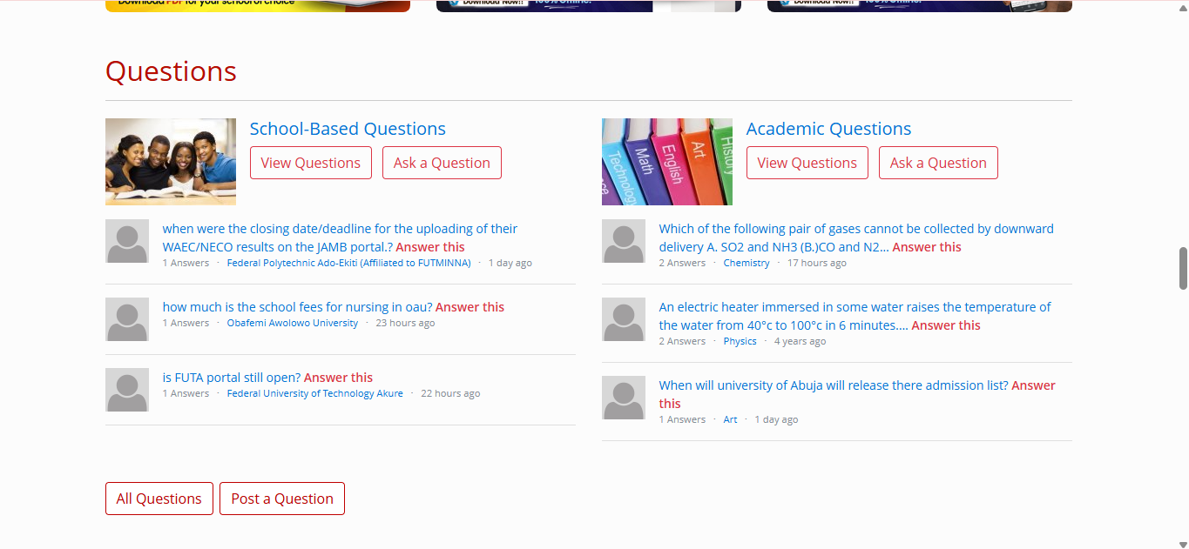

Figure 2.5 User Interface of Myschool.ng

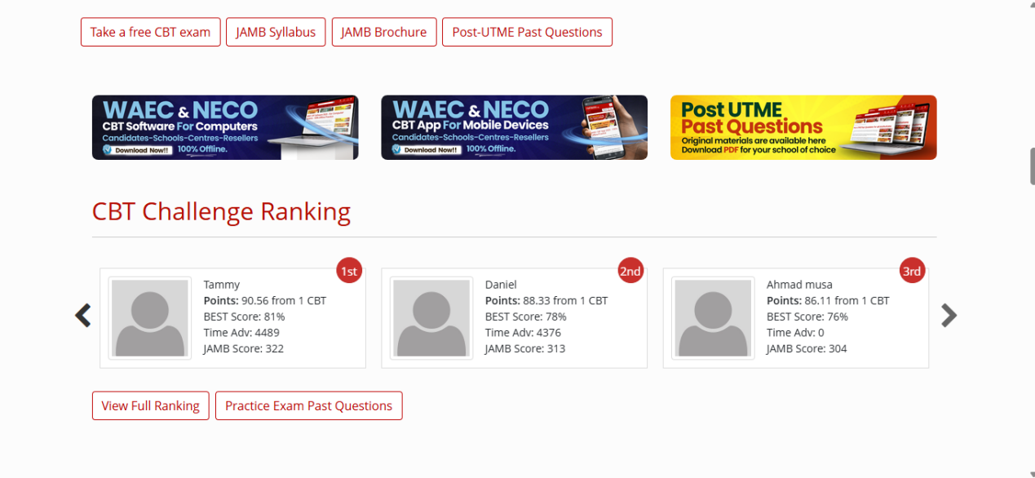

Figure 2.6 User Interface of Myschool.ng

**2.4.2.2 ULesson**

ULesson is an African edtech company that provides a platform where primary and secondary school students can watch high quality video lessons, engage in interactive quizzes, and get help with their homework.

Features

1. Utilizing video lessons and animations to teach students.
2. Quizzes and assessments that students can answer individually or as a group.
3. Mock examinations to help students adequately prepare for their main examinations.
4. Real time access to learners progress report.
5. Chat to ask questions and get answers from tutors.

Strengths

1. Allows students to learn at their own pace.
2. Offers personalized video lessons that are also in line with the curriculum.
3. Available across multiple devices (web browsers and mobile applications).
4. Reduces educational inequality by providing access to quality teachers remotely.

Limitations

1. Subscription fees are a barrier for many especially with the current state of Nigeria's economy.
2. Dependent on internet access to stream video lessons which may not be accessible to students in remote areas.
3. Limited to primary and secondary school students.

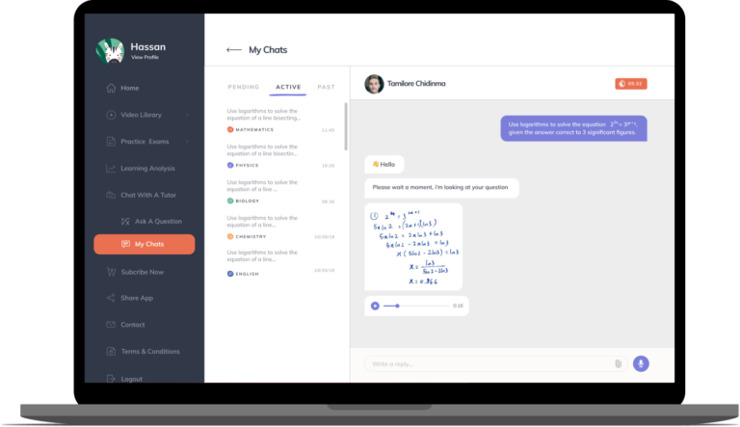

Figure 2.7 User Interface of ULesson

(Ore Badmus, 2021)

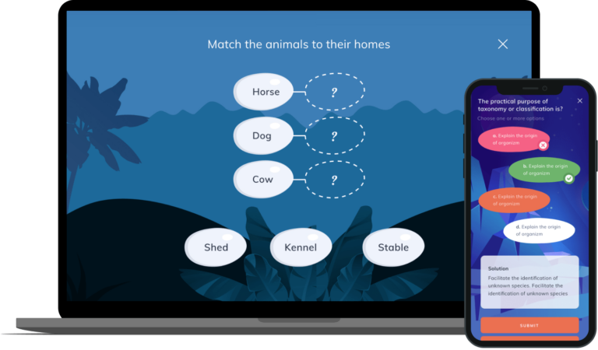

Figure 2.8 User Interface of ULesson

(Badmus, 2021)

**2.5 Summary**

This chapter showed the review process of the literature regarding the numerous technologies and resources used through the development process. The Historical overview shows how education evolved over the years to implement technology in teaching and learning. The platform being developed recognizes these gaps and strives to provide solutions tailored to the needs of university students in various Nigerian universities. Chapter 3 will discuss the requirements and the methodology that has been used to solve the stated issue, including the provision of diagrams like the Use case, Activity. ERD etc.

**Table 2.1 Related works summary**

|  |  |  |
| --- | --- | --- |
| **Application Name** | **Features** | **Limitations** |
| Moodle | Course creation and management (admins, educators)  Assessment creation and management  Learner progress tracking (activity, course completion, reports)  Badges and certificates for achievements  Drag-and-drop course building  Plugins for extra functionality  Integration with Microsoft Teams, Zoom, etc.  Mobile and tablet compatibility  Offline access for downloaded courses | No built-in gamification (needs plugins)  Limited support for some content types and sizes  Key tools (e.g., video conferencing) depend on plugins/extensions |
| Google Classroom | Stream for announcements and discussions  Assignment creation, grading, and sharing of academic material  Student collaboration (viewing, turning in, peer work)  Teacher invitation to join class  Messaging and feedback on assignments  Integration with Google Drive, Docs, Sheets, Meet  Push notifications via Gmail  Browser and mobile app access | Requires stable internet connection  Limited analytics and progress monitoring tools  Weak integration with non-Google platforms  Lacks in-built gamification features |
| Kahoot! | User-created games (“kahoots”)  Interactive sessions with shared screens  Self-paced quiz assignments  Team-based challenges  Multiple quiz formats (MCQs, true/false, puzzles, open-ended)  Instant polls and feedback  Leaderboards and scoring systems  Student progress tracking  Accessible on browsers and apps | Advanced features locked behind paid plan  Focused only on quiz-based activities  User-generated content may lack quality or accuracy  Needs strong internet connectivity  Competitive style can cause student anxiety |
| Myschool.ng | Large database of past JAMB/WAEC questions  CBT simulation with customizable exam settings  Video lessons and tutorials for core subjects  Offline download of materials  Peer and teacher Q&A forums  Updates on school/exam information  Leaderboard ranking for users | Frequent app/site errors and crashes  Multiple device login issues (activation requests)  Focused mainly on secondary school level  Weak customer care service |
| uLesson | Video lessons and animations aligned with curriculum  Quizzes and assessments (individual and group)  Mock examinations for practice  Real-time learner progress reporting  Tutor chat/help support  Multi-device support (browser + mobile apps) | Subscription fees restrict access for many  Internet dependence for video streaming  Limited to primary and secondary school students |

**CHAPTER 3**

**REQUIREMENTS, ANALYSIS, AND DESIGN**

**3.1 Overview**

This chapter will give an overview of the requirements for the application and the design and architecture of the proposed project. The requirement gathering phase involved determining the functional and non-functional requirements through surveys and observation. Visual representations such as the use case diagram, entity relationship diagram, activity diagram and so on have been used to depict the system design.

**3.2 Adopted Methodology**

Software Development methodologies are frameworks for planning, structuring, and managing the software development process (Nikitin, 2024). The proposed project was developed by adopting the ‘Incremental Model’. This methodology was chosen because it breaks the development into smaller, stand alone phases, called increments. This way, each increment will produce a fully functional part of the software, while other modules will continue to be developed until the entire project is completed. Each phase will produce a working module that can be presented to end-users.

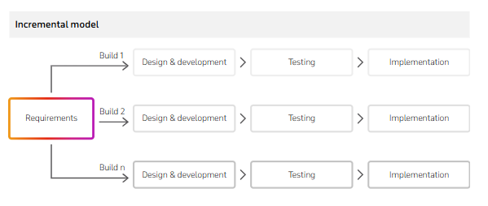

**Figure 3.1: Incremental Model (Nikitin, 2024)**

The incremental model is particularly suitable for this project because the requirements are clearly defined and can be built as separate increments. The requirements include: user authentication, academic material management (upload and download), quizzes, and leaderboard features. A strict plan for the increments will be made in order to avoid potential risks, and to make it valuable to the end user. This model allows for modularity (dividing a system into modules that carry out a specific function).

Other methodologies such as Waterfall and Agile models were considered but were not fit for the development process. The Waterfall model follows a linear model, requiring that all requirements be fully gathered, analyzed, and documented, leaving little or no room for adjustments in the later stages. The Agile model on the other hand is flexible and values an iterative approach in development. However, stakeholder collaboration is a prerequisite which means that stakeholder involvement and communication are frequent and necessary for this model. Both models are simply not practical enough for building a student-centered application. In contrast, the Incremental model allows for incremental development, enabling gradual development and testing without the overhead of Agile and rigidity of Waterfall.

**3.3 Tools and Techniques**

In order to ensure the successful implementation of the application, appropriate programming tools and techniques were employed. These tools include:

1. Next.js: next.js is a react framework used for building full-stack web applications. It enables client-side and server-side development.
2. Mongodb: mongodb is a NoSQL database manager. It does not have relational databases. The data is stored in BSON (Binary JSON) documents within collections.
3. npm: npm stands for Node.js Package Manager. It is a manager for javascript packages and their dependencies.

These technologies allowed me to build a reliable web app that positively impacts the academic lives of Nigerian computer science students.

**3.4 Requirements Analysis**

**3.4.1 Functional Requirements Specifications**

**Table 3.1: Functional requirements of the students**

|  |  |
| --- | --- |
| **Req. No** | **Description** |
| FR-1 | The system should allow students to create an account (Register/Sign up). |
| FR-2 | The system should allow students to login securely with email and password |
| FR-3 | The system should allow students to upload academic material with supported file types (PDF, DOC, JPG, PNG, PPT etc.). |
| FR-4 | The system should allow students to view uploaded materials and download the uploaded materials into their device. |
| FR-5 | The system should allow students to attempt quizzes |
| FR-6 | The system should allow students to receive instant results after quiz attempt |
| FR-7 | The system should allow students to join competition quizzes |
| FR-8 | The system should allow students to view their competition score and quiz history on their profile. |
| FR-9 | The system should allow students see their rank on a leaderboard for competition quizzes |
| FR-10 | The system should allow students to search/filter materials by course, category, and difficulty level. |

**Table 3.2: Functional requirements of the admin**

|  |  |
| --- | --- |
| **Req. No** | **Description** |
| FR-101 | The system should allow admins to create an account (Register/Sign up). |
| FR-102 | The system should allow admins to review, approve, and reject material uploads. |
| FR-103 | The system should allow admins to manage users (assign roles, remove users) |
| FR-104 | The system should allow admins to create quizzes |
| FR-106 | The system should allow admins to edit, publish, unpublish, and delete quizzes |
| FR-105 | The system should allow admins to manage quizzes and competitions (timeframe, number of attempts) |
| FR-106 | The system should allow admins to monitor and manage leaderboards exclude students) |

**3.4.1 Non-Functional Requirements Specifications**

**Table 3.3: Non-Functional requirements**

|  |  |  |
| --- | --- | --- |
| **Req. No** | **Description** | **Type** |
| NFR-1 | The system should safely store users data | Security |
| NFR-2 | The system should run on all major browsers (Chrome, Firefox, Edge) | Compatibility |
| NFR-3 | The system should be user friendly | Usability |
| NFR-4 | The system should run properly across multiple devices (mobile, PC) | Usability/Portability |
| NFR-5 | The system should be available 24/7 with minimal downtime | Availability |
| NFR-6 | Students personal data must be protected and only accessible to the authorized user | Privacy |
| NFR-7 | Uploaded files and quiz results must remain authentic and unchanged | Data Integrity |
| NFR-8 | The system should support at least 100 concurrent users without slowing down or crashing | Performance |
| NFR-9 | The system should provide results quickly if the result doesn’t rely on user input | Performance |
| NFR-10 | Data on the system must not be lost | Reliability |
| NFR-11 | The system should allow adding more features | Scalability |
| NFR-12 | The systems code should be modular and easily updatable | Maintainability |

**3.5 System Design**

**3.5.1 Application Architecture**

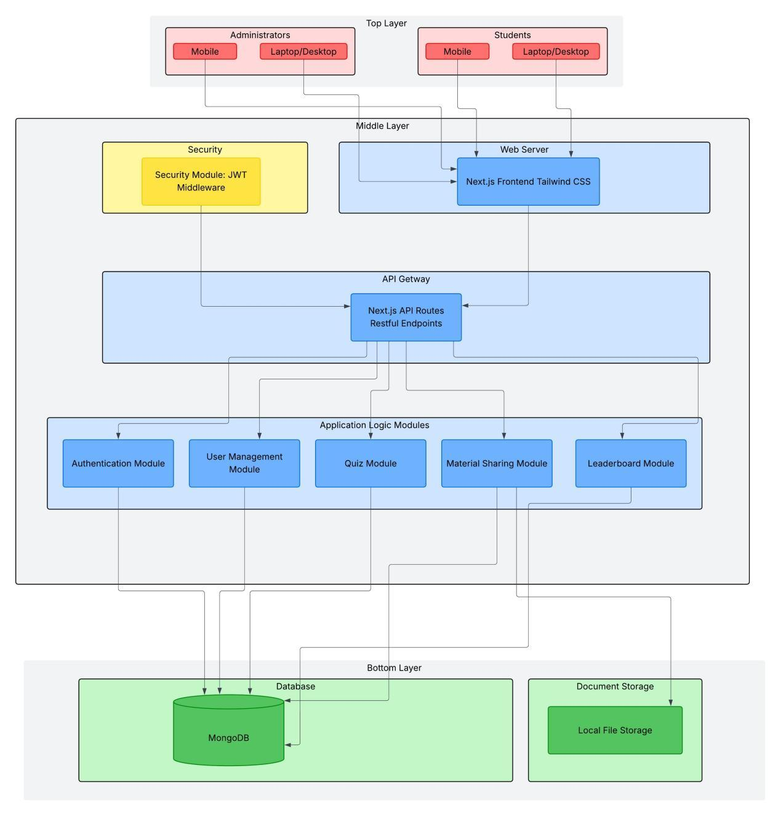

Figure 3.2: Application Architecture Diagram

**3.5.2 Use Case Diagram**

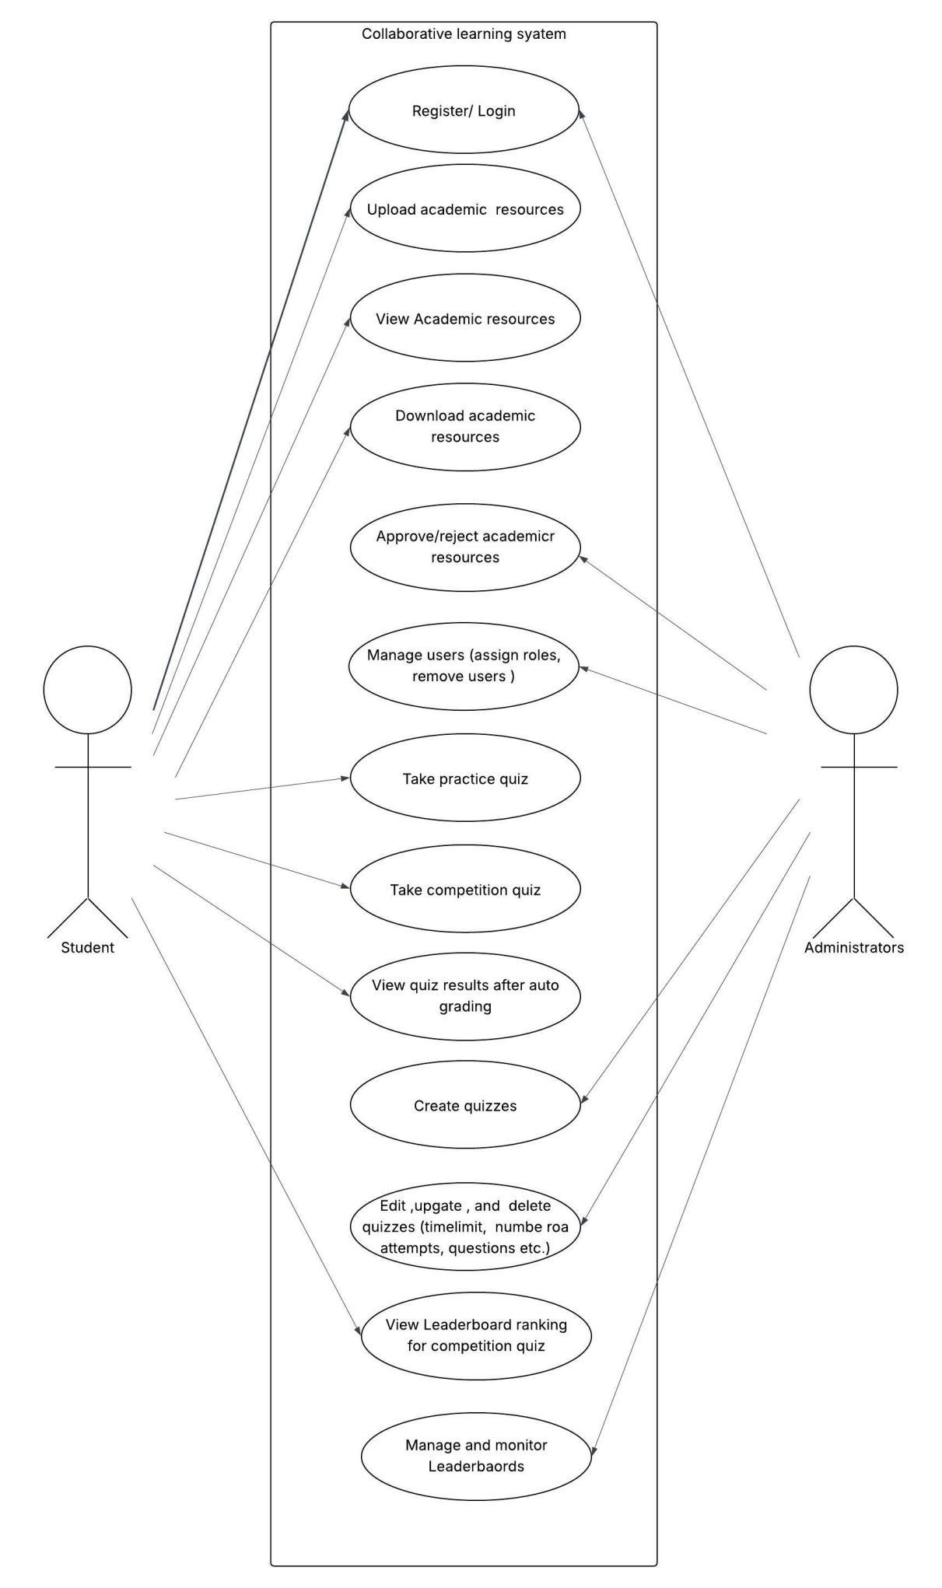

Figure 3.3: Use Case Diagram

**Table 3.3: Use-Case Description for Register**

|  |  |  |
| --- | --- | --- |
| Use Case: | Register | |
| Description: | This use case describes the process of registering in the Collaborative Academic Platform for Computer Science Students with Inter-University Leader board Competitions | |
| Actors: | User | |
| Preconditions: | None | |
| Postconditions: | If registration succeeds, the user is redirected to the system. If registration fails system state is unchanged | |
| Main flow: | User:  User clicks on the register button  If the user clicks on register, the user provides the required credentials | System:  The system validates and stores the provided registration details  If the registration is successful, the user is redirected to the application  Use case ends |
| Exception condition: | Missing or incorrect registration credentials results in an error message.  Users can retry or cancel, ending the use case. | |

**Table 3.4: Use-Case Description for Login**

|  |  |  |
| --- | --- | --- |
| Use Case: | Login | |
| Description: | This use case describes the process of logging into the Collaborative Academic Platform for Computer Science Students with Inter-University Leader board Competitions | |
| Actors: | User | |
| Preconditions: | User has previously successfully registered into the system | |
| Postconditions: | If login succeeds, the user is logged into the system. If login fails system state is unchanged | |
| Main flow: | User:  User clicks on the login button  If the user clicks on login, the user provides their login credentials | System:  The system validates and the provided login details  If the login is successful, the user is logged into the application  Use case ends |
| Exception condition: | Invalid login credentials result in an error message.  Users can retry or cancel, ending the use case. | |

**Table 3.5: Use Case Description for Material upload**

|  |  |  |
| --- | --- | --- |
| Use Case: | Document Upload | |
| Description: | This use case describes how students upload academic material in the application. | |
| Actors: | Students | |
| Precondition: | Student is logged into the system | |
| Postcondition: | After uploading, the material is approved or rejected by the administrator. If the administrator approves, it will be uploaded into the application and will be visible to all users. If the administrator rejects, it will not be uploaded into the application. | |
| Main Flow: | Student:  Student click on the upload material link  Student selects a file from their system and enters the file details  Student clicks the upload material button | System:  System sets the uploaded material status to pending  System takes the uploaded material to the administrator side for approval or rejection  If the administrator approves, the system sets the status to approved and displays it in the view materials page in the application.  If the administrator rejects it, the system sets the materials status to rejected and it will not be visible in the application. |
| Exception Conditions | If the user doesn’t fill in all the credentials for uploading the material, the system will not allow upload. | |

**Table 3.6: Use Case Description for Quiz Taking**

|  |  |  |
| --- | --- | --- |
| Use Case: | Quiz taking | |
| Description: | This use case describes how students take quizzes in the application | |
| Actors: | Students | |
| Precondition: | Student is logged into the system | |
| Postcondition: | Quiz result is displayed | |
| Main Flow: | Student:  Student click on the start quiz button  Student selects an option for question  Student clicks on the submit button | System:  The system receives the students' quiz attempts.  Systems returns and displays the auto calculated results. |
| Exception Conditions | If the student has used up all their quiz attempts, the system will display an error message.  If the student doesn’t answer all questions, they will not be allowed to submit. | |

**Table 3.7: Use-Case Description for Quiz Creation**

|  |  |
| --- | --- |
| Use Case: | Quiz Creation |
| Description: | This use case describes how administrators create quizzes in the application |
| Actors: | Administrator |
| Preconditions: | Administrator is logged into the system |
| Postconditions: | If quiz creation succeeds, administrators can edit the quiz, add questions, publish, and unpublish the quiz. |
| Main flow: | Administrator:  Administrator click on create new quiz button  Administrator enters quiz details and selects either practice or competition quiz  Administrator clicks on the create quiz button |
| Exception condition: | Incomplete quiz details when creating will not allow for creation. |

**Table 3.8: Use-Case Description for Approval/Rejection of Materials**

|  |  |  |
| --- | --- | --- |
| Use Case: | Material Approval/Rejection | |
| Description: | This use case describes how administrators approve and reject quizzes materials on the application | |
| Actors: | Administrator | |
| Preconditions: | Administrator is logged into the system  A student has uploaded a material into the system | |
| Postconditions: | If a material is approved, it becomes visible to users and downloadable by users  If a material is rejected, it is not uploaded on the application and cannot be viewed | |
| Main flow: | Administrator:  Administrator click on Materials page in admin dashboard  Administrator previews the material then either clicks on the approve button the approve it or click on the reject button to reject it | Systems:  The system uploads the material into the application for viewing if its approved  The system deletes the material from the application if its rejected |
| Exception condition: | None | |

**Table 3.9: Use Case Description for Viewing Materials**

|  |  |
| --- | --- |
| Use Case: | View Materials |
| Description: | This use case describes how students view academic material in the application. |
| Actors: | Students |
| Precondition: | Student is logged into the system |
| Postcondition: | Preview and download materials. |
| Main Flow: | Student:  Student click on the view material link  Student selects a material to view in the application by clicking on the preview button  Student clicks on the download button to download the material into their device |
| Exception Conditions | None |

**Table 3.10: Use Case Description for Viewing Leaderboard**

|  |  |
| --- | --- |
| Use Case: | View Leaderboard |
| Description: | This use case describes how students view leaderboards academic material in the application. |
| Actors: | Students |
| Precondition: | A competition quiz must have been published |
| Postcondition: | Leaderboard is displayed depending on the selected quiz |
| Main Flow: | Student:  Student navigates to the leaderboard page  Students select which competition quiz they want to view the leaderboard of.  The leaderboard is displayed for the student to see. |
| Exception Conditions | If there are no published competition quizzes there will be no leaderboard. |

**3.5.3 Entity Relationship Diagram**

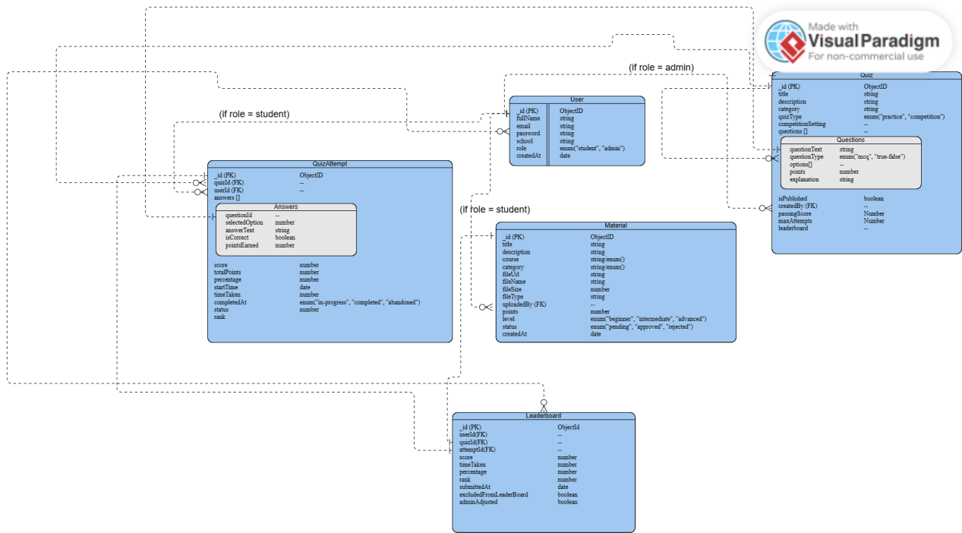

Figure 3.4: Entity Relationship Diagram

**3.5.4 Activity Diagrams**

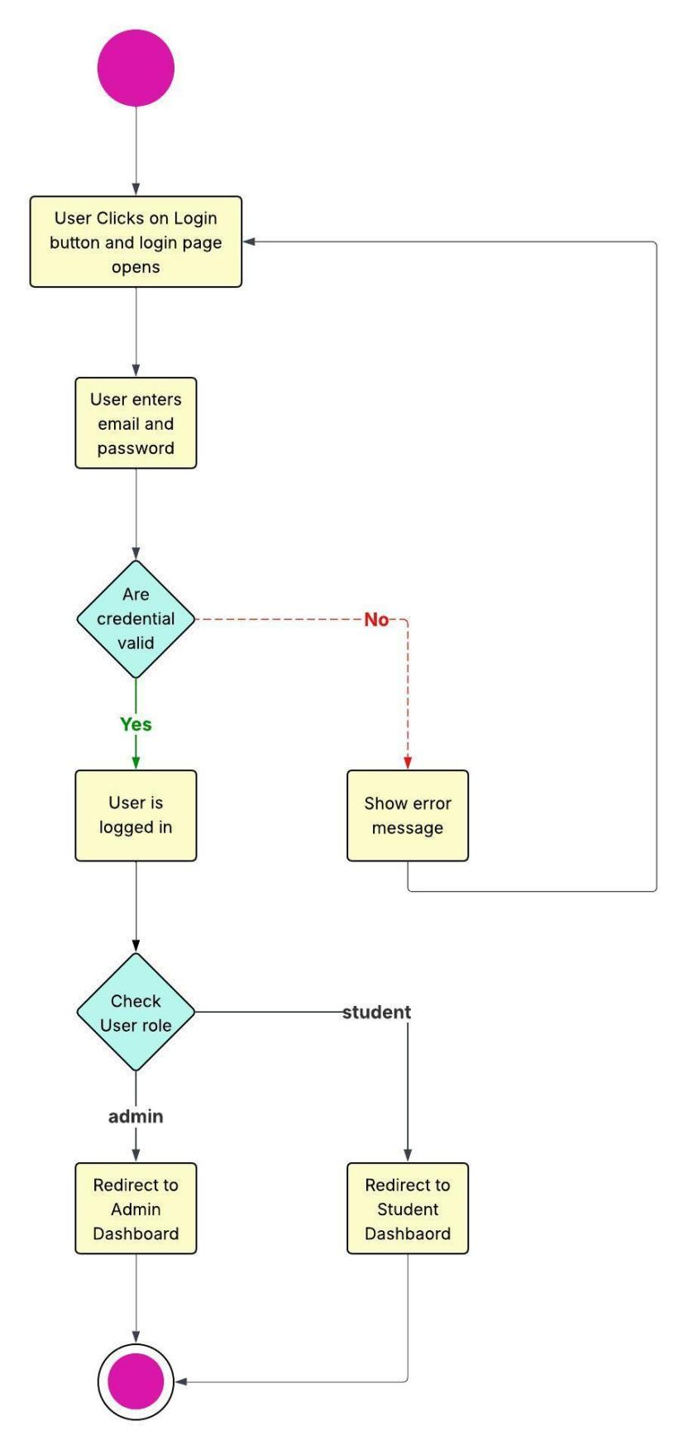

Figure 3.5: Login Activity Diagram

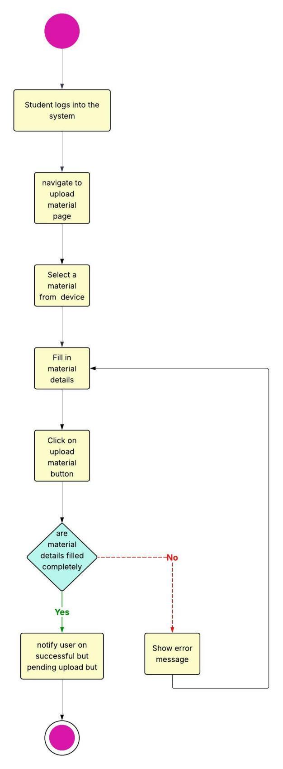

Figure 3.6: Upload Material Activity Diagram (Student)

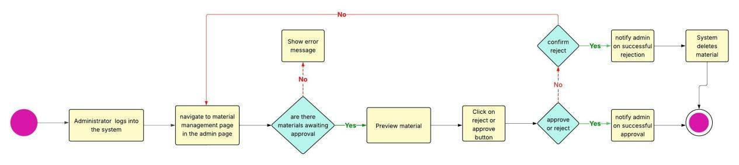

Figure 3.7: Approve/Reject Material Activity Diagram (Administrator)

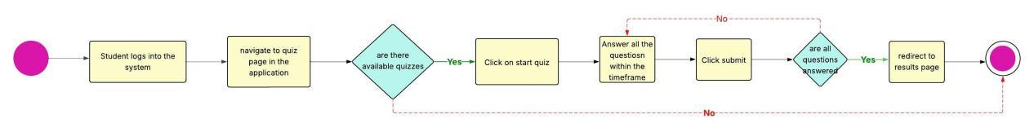

Figure 3.8: Quiz Taking Activity Diagram (Student)



Figure 3.9: Quiz Creation Activity Diagram (Administrator)

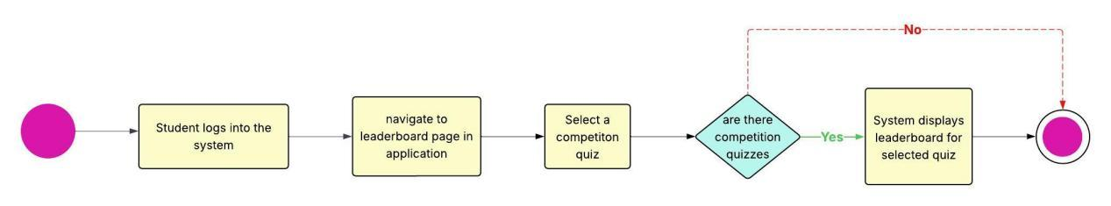

Figure 3.10: View Leaderboard Activity Diagram

**3.5.5 Dataflow Diagram**

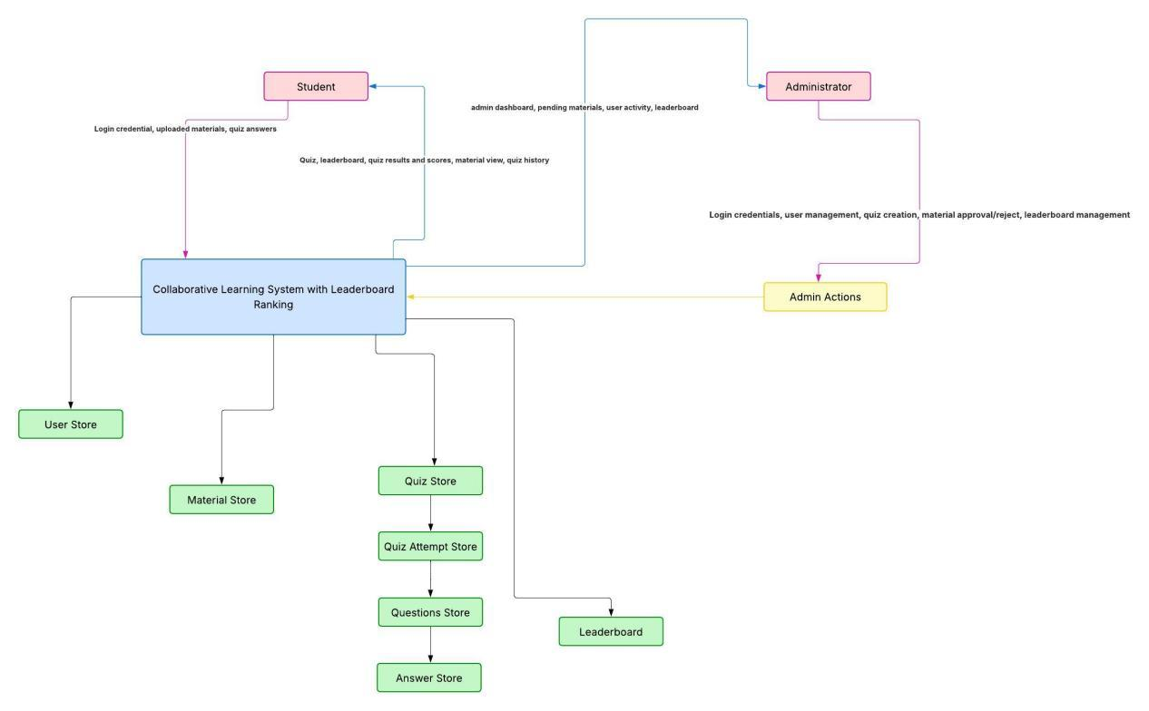

Figure 3.11: Dataflow Diagram

**3.5.6 Control Flow Diagram**

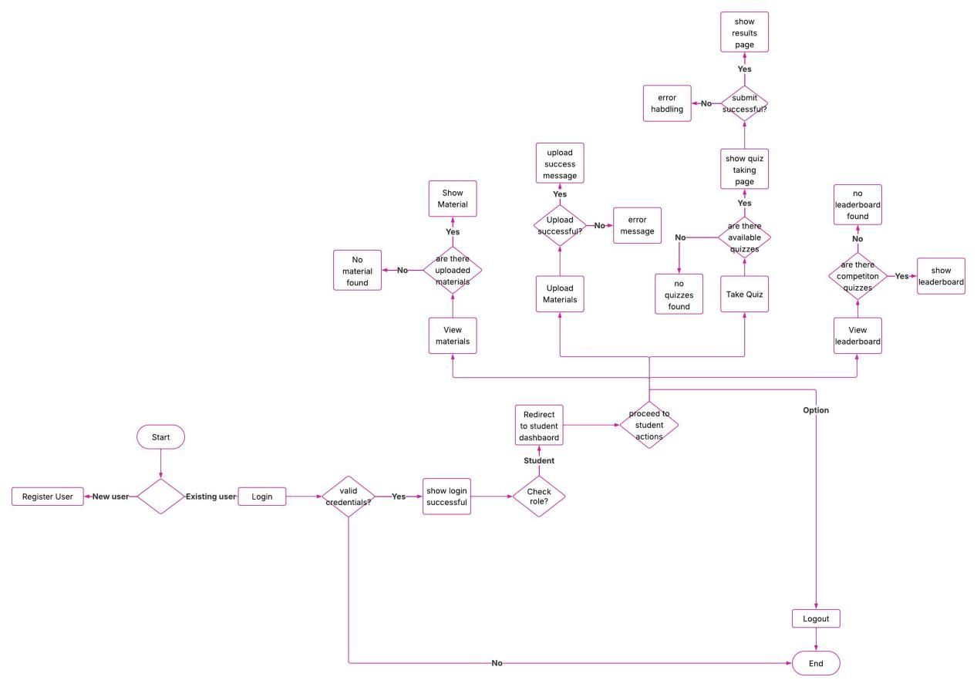

Figure 3.12: Control Flow Diagram for Students

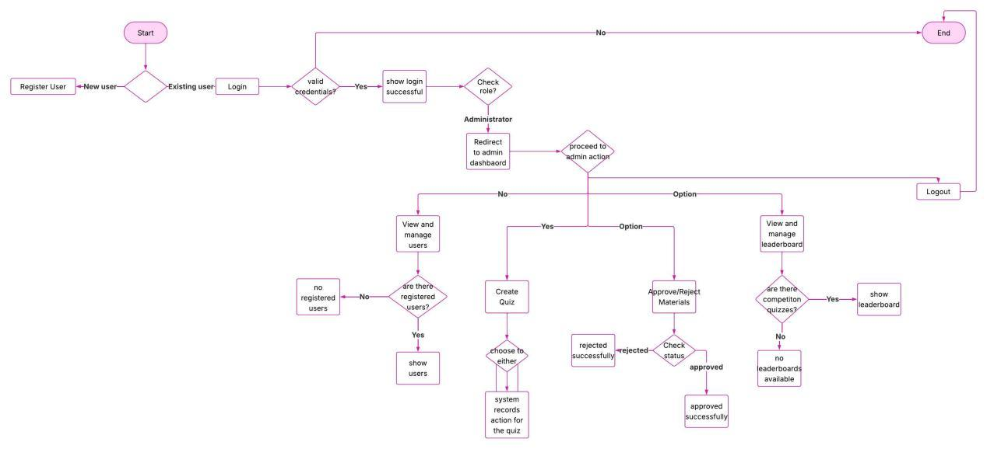

Figure 3.13: Control Flow Diagram for Administrators

**3.5.7 User Interface Design**

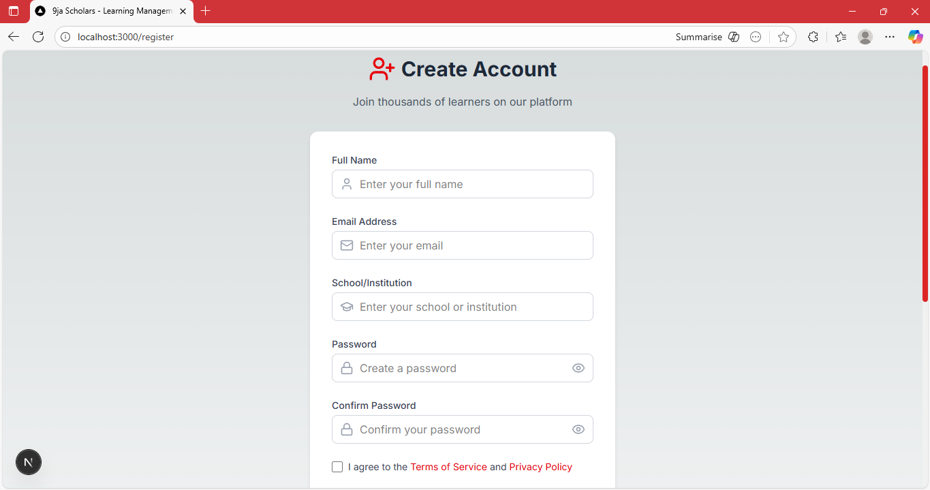

Figure 3.14: Registration Page

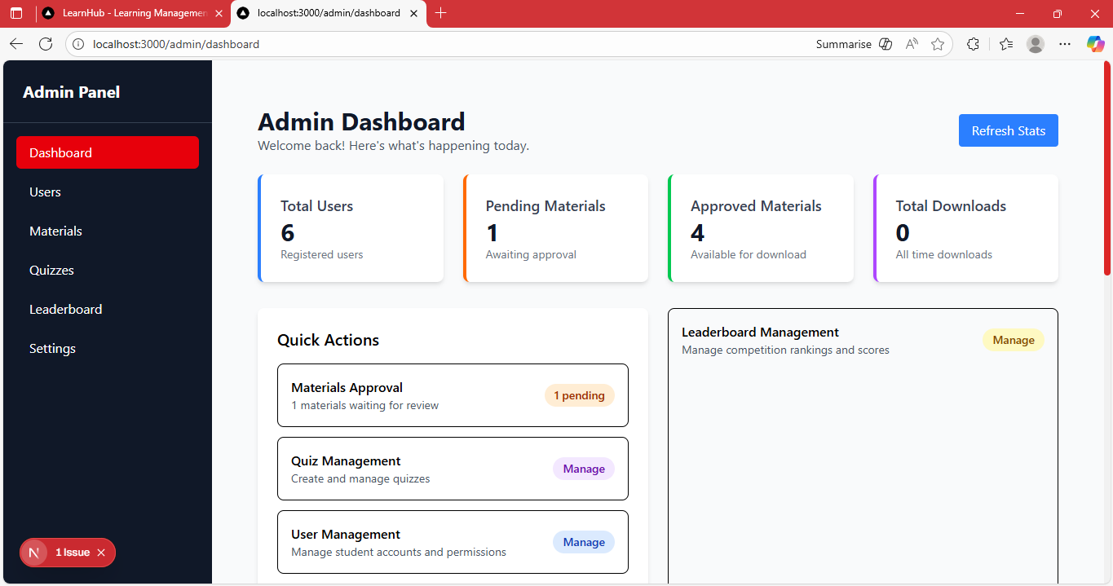

Figure 3.15: Admin Dashboard

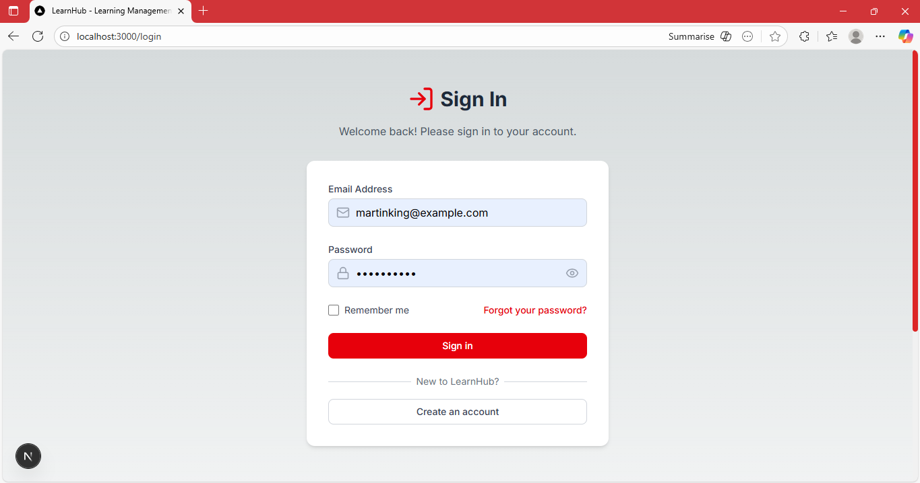

Figure 3.16: Login page

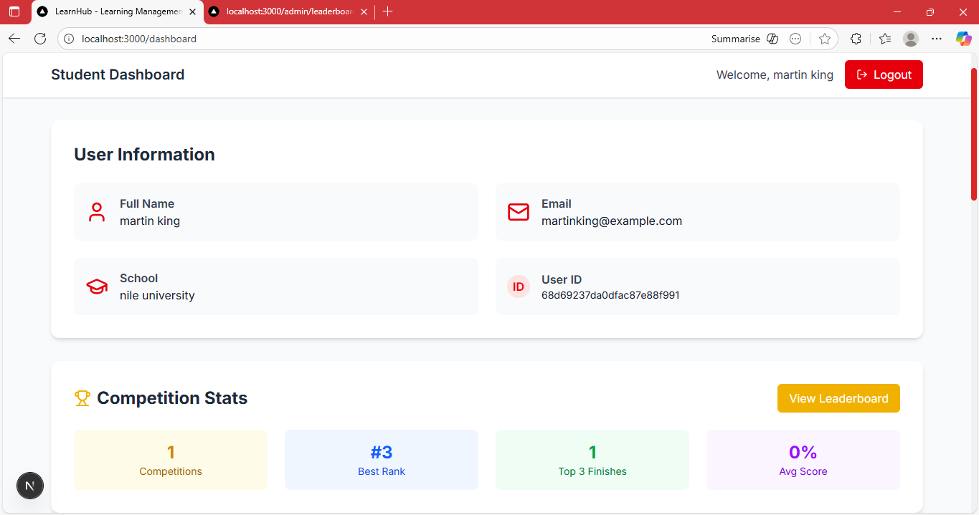

Figure 3.17: Student dashboard

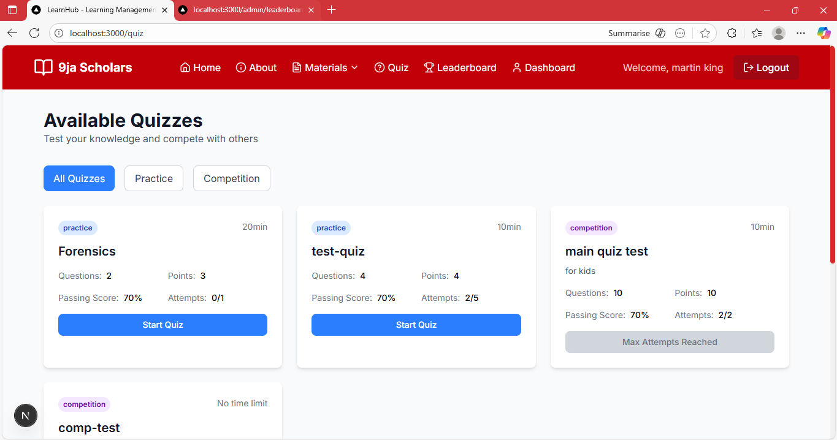

Figure 3.18: Available Quizzes page (student)

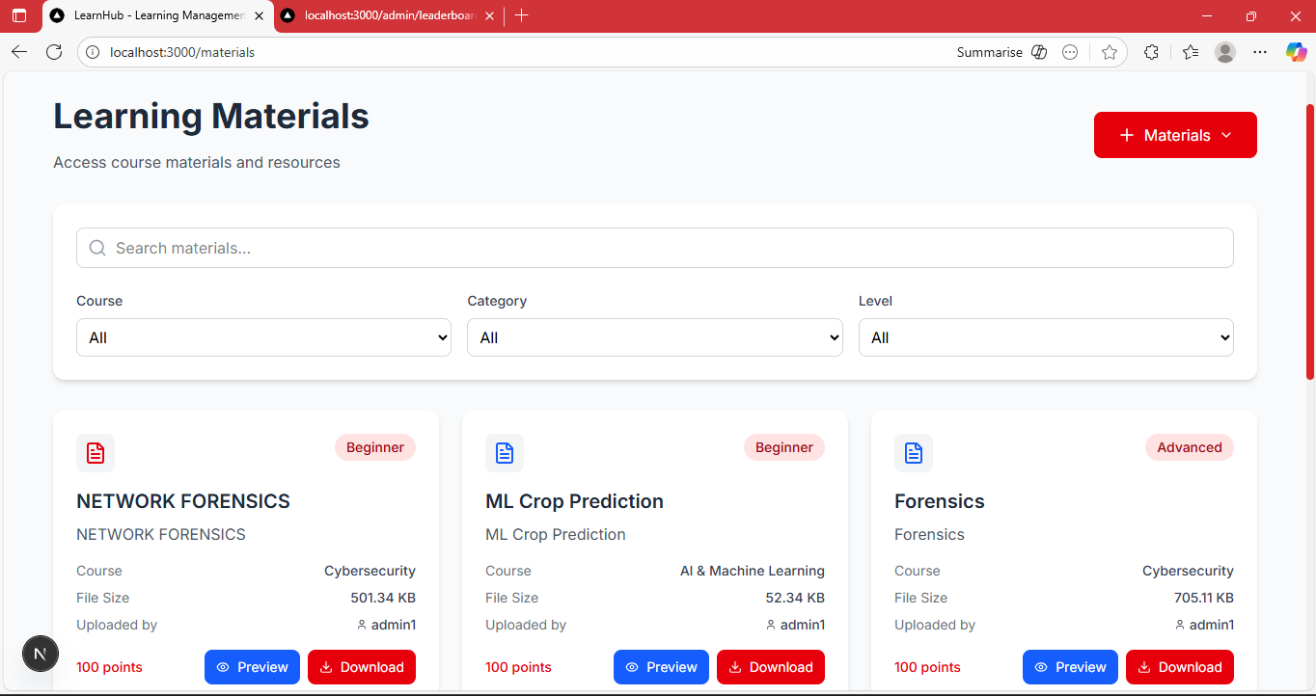

Figure 3.19: View Materials page (student)

**3.6 Summary**

This chapter showed the design and architecture of the system. When developing a system, designing is the bedrock for a smooth and successful implementation of the application. Chapter four will cover the implementation of the web application and various tests carried out to ensure reliability.

**CHAPTER 4**

**IMPLEMENTATION AND TESTING**

**4.1 Overview**

This chapter highlights the implementation of the collaborative learning system with a leaderboard feature integrated for computer science students across Nigerian universities. It covers the main features of the application, the issues during the implementation process, the strategies used to overcome those issues, and the testing carried out to ensure the application functions as expected.

**4.2 Main Features**

The main features of the learning system are as follows:

1. User Registration and Login: The application has a secure authentication system which allows new users to register, and successfully registered students to login using their email and password. The default role for every user registering is a student, users who want to be an administrator will be changed to an administrator and will have access to the administrator dashboard.
2. Academic Material View, Upload, and Download: Students can upload materials that other users can view and download into their devices.
3. Academic Material Management: Every material uploaded by a user is approved by the administrator to ensure that it meets the standard. If the material doesn’t meet up to standard, the administrator can reject the material which means students won’t see it when viewing uploaded materials.
4. Quiz Taking: Students can take quizzes that are published on the application. There are two types of quizzes that a student can participate in: practice quiz and competition quiz. The practice quizzes are for testing purposes, while the competition quizzes are taken for the purpose of competing with other students to be ranked on a leaderboard.
5. Quiz Creation and Management: in the application, quizzes are created by administrators. They create, edit(time limit, attempts, questions), publish, and unpublish quizzes.
6. Leaderboard: Students can view their rank on the leaderboard for any competition quiz they take part in. They see their performance compared to other participants.
7. Leaderboard Management: Administrators monitor and can edit the leaderboard if there is any form of foul play or incorrect judgement involved.
8. User Management: The application provides an interface for administrators to manage user accounts. They can remove users and assign roles and permissions.

**4.3 Implementation Problems**

While implementing the collaborative learning system, various challenges were encountered. The major problems faced include:

1. Testing and Debugging: testing the system to identify errors and bugs is necessary but often leads to frustration and delays during the implementation process.
2. Learning a new language: adopting new technologies like Next.js and MongoDB required me to be knowledgeable on their syntax and usage. It was challenging considering the little timeframe given to learn and implement these technologies.
3. Time Constraints: the time frame for documenting and building an application for the project was tight. Due to this, some minor features were omitted in order to meet up with the deadline.
4. Authentication and Authorization: implementing the secure registration that differentiates students from administrators was challenging. They have different privileges and rights and secure authentication has to be properly executed to avoid security and integrity issues.

**4.4 Overcoming Implementation Problems**

The aforementioned problems were overcome by employing strategic methods and techniques:

1. Testing and Debugging: testing after implementing a module allowed for early identification of bugs and errors. Also, utilizing tools like stack overflow helped find solutions to code problems being faced.
2. Learning a new language: watching tutorial videos and reading official documentation on the technologies were useful for getting proficient in them.
3. Time Constraints: proper planning and implementing the incremental model during development helped with time management and delivering a quality application.
4. Authentication and Authorization: including user roles (admin and students) and creating middleware functions that check access to protected routes was key to differentiating users.

**4.5 Testing**

To ensure the systems quality and reliability, robust testing was employed. The testing process involved the following phases:

**Table 4.1: Testing for User Registration**

|  |  |
| --- | --- |
| Test case | User Registration |
| Related Page | Registration Page |
| Test Procedure | Click on the “Register” button  Enter the required details for registration (full name, email, school, password)  Check the Privacy policy agreement box  Click on the “Create Account” button |
| Test Data | User Details |
| Expected results | Registration Successful! Redirecting… |
| Actual results | Registration Successful! Redirecting… |
| Status | Pass |
| Remarks | none |
| Created By | Christos Sochinenyenwa Ebeatu |
| Date of creation | 26th September, 2025 |
| Executed by | Christos Sochinenyenwa Ebeatu |
| Date of Execution | 26th September, 2025 |
| Test Environment | Hp Laptop |

**Table 4.2: Testing for User Login**

|  |  |
| --- | --- |
| Test case | User Login |
| Related Page | Login Page |
| Test Procedure | Click on the “Login” button  Enter the required details for login (email and password)  Click on the “Sign in” button |
| Test Data | User Login Details |
| Expected results | Login Successful! Redirecting… |
| Actual results | Login Successful! Redirecting… |
| Status | Pass |
| Remarks | None |
| Created By | Christos Sochinenyenwa Ebeatu |
| Date of creation | 26th September, 2025 |
| Executed by | Christos Sochinenyenwa Ebeatu |
| Date of Execution | 26th September, 2025 |
| Test Environment | Hp Laptop |

**Table 4.3: Testing for View Users**

|  |  |
| --- | --- |
| Test case | View Users |
| Related Page | Admin dashboard |
| Test Procedure | 1.Click on “Users” on the admin panel  2. List of Users is fetched |
| Test Data | None |
| Expected results | List of all users displayed |
| Actual results | List of all users displayed |
| Status | Pass |
| Remarks | none |
| Created By | Christos Sochinenyenwa Ebeatu |
| Date of creation | 26th September, 2025 |
| Executed by | Christos Sochinenyenwa Ebeatu |
| Date of Execution | 26th September, 2025 |
| Test Environment | Hp Laptop |

**Table 4.4: Testing for Create Quiz**

|  |  |
| --- | --- |
| Test case | Create Quiz |
| Related Page | Admin dashboard |
| Test Procedure | 1.Click on “Quizzes” on the admin panel  2. List of existing quizzes is fetched  3. Click on “Create New Quiz”  4. Enter quiz details (Quiz title, category, Quiz Type)  5. Click on “Create Quiz” |
| Test Data | None |
| Expected results | “Quiz created successfully”. Administrator can now edit, publish, or delete the quiz |
| Actual results | “Quiz created successfully”. Administrator can now edit, publish, or delete the quiz |
| Status | Pass |
| Remarks | None |
| Created By | Christos Sochinenyenwa Ebeatu |
| Date of creation | 26th September, 2025 |
| Executed by | Christos Sochinenyenwa Ebeatu |
| Date of Execution | 26th September, 2025 |
| Test Environment | Hp Laptop |

**Table 4.5: Testing for Materials Approve/Reject**

|  |  |
| --- | --- |
| Test case | Materials Approve/Reject |
| Related Page | Admin dashboard |
| Test Procedure | 1.Click on “Material” on the admin panel  2. List of pending materials is fetched  3. Click on “Preview” button to preview material or download if preview is not available  4. Click on “Reject” or Click on “Approve” |
| Test Data | Uploaded materials |
| Expected results | Approve: “Material approved successfully!”  Reject: “Are you sure you want to reject material?”  OK - “Material rejected successfully!”  Cancel - Confirmation alert closes |
| Actual results | Approve: “Material approved successfully!”  Reject: “Are you sure you want to reject material?”  OK - “Material rejected successfully!”  Cancel - Confirmation alert closes |
| Status | Pass |
| Remarks | None |
| Created By | Christos Sochinenyenwa Ebeatu |
| Date of creation | 26th September, 2025 |
| Executed by | Christos Sochinenyenwa Ebeatu |
| Date of Execution | 26th September, 2025 |
| Test Environment | Hp Laptop |

**Table 4.6: Testing for View Leaderboard (Admin)**

|  |  |
| --- | --- |
| Test case | View Leaderboard |
| Related Page | Admin dashboard |
| Test Procedure | 1.Click on “leaderboard” on the admin panel  2. List of competition quizzes is fetched  3. Click on the quiz that you would like to view the leaderboard of  4. Leaderboard is fetched |
| Test Data | None |
| Expected results | Leaderboard of the competition quiz selected |
| Actual results | Leaderboard of the competition quiz selected |
| Status | Pass |
| Remarks | None |
| Created By | Christos Sochinenyenwa Ebeatu |
| Date of creation | 26th September, 2025 |
| Executed by | Christos Sochinenyenwa Ebeatu |
| Date of Execution | 26th September, 2025 |
| Test Environment | Hp Laptop |

**Table 4.7: Testing for View Materials**

|  |  |
| --- | --- |
| Test case | View Materials |
| Related Page | Materials page |
| Test Procedure | 1.Click on “Materials” navigation bar to reveal a dropdown  2. Click on “View Materials” on the dropdown.  3. Available Materials are fetched  4. Search for a specific material or filter by course, category and level |
| Test Data | Keyword for searching |
| Expected results | List of all materials displayed |
| Actual results | List of all materials displayed |
| Status | Pass |
| Remarks | None |
| Created By | Christos Sochinenyenwa Ebeatu |
| Date of creation | 26th September, 2025 |
| Executed by | Christos Sochinenyenwa Ebeatu |
| Date of Execution | 26th September, 2025 |
| Test Environment | Hp Laptop |

**Table 4.8: Testing for Upload Materials**

|  |  |
| --- | --- |
| Test case | Upload Materials |
| Related Page | Materials page |
| Test Procedure | 1.Click on “Materials” navigation bar to reveal a dropdown  2. Click on “Add Material” on the dropdown  3. Select a file from your device  4. Enter required details for upload (title, course, category, level, description)  5. Click on “Upload Material” |
| Test Data | Material details |
| Expected results | “Material uploaded successfully! It will be visible after admin approval” |
| Actual results | “Material uploaded successfully! It will be visible after admin approval” |
| Status | Pass |
| Remarks | None |
| Created By | Christos Sochinenyenwa Ebeatu |
| Date of creation | 26th September, 2025 |
| Executed by | Christos Sochinenyenwa Ebeatu |
| Date of Execution | 26th September, 2025 |
| Test Environment | Hp Laptop |

**Table 4.9: Testing for Taking Quiz**

|  |  |
| --- | --- |
| Test case | Take Quiz |
| Related Page | Quiz page |
| Test Procedure | 1.Click on “Quiz” on the navigation bar  2. Available quizzes are fetched  3. Click on “Start Quiz”  4. Answer questions by selecting options  5. Click “Next Question” to go to the next question  5. Click on “Submit”  6. Score and performance summary is displayed |
| Test Data | Answers to given questions |
| Expected results | Quiz for taking with a timer  Quiz results |
| Actual results | Quiz for taking with a timer  Quiz results |
| Status | Pass |
| Remarks | None |
| Created By | Christos Sochinenyenwa Ebeatu |
| Date of creation | 26th September, 2025 |
| Executed by | Christos Sochinenyenwa Ebeatu |
| Date of Execution | 26th September, 2025 |
| Test Environment | Hp Laptop |

**Table 4.10: Testing for View Leaderboard (Student)**

|  |  |
| --- | --- |
| Test case | View Leaderboard |
| Related Page | Leaderboard page |
| Test Procedure | 1.Click on “Leaderboard” on the navigation bar  2. Select a competition quiz  3. Leaderboard is fetched (top three participants and the full leaderboard) |
| Test Data | None |
| Expected results | Top three podium and full leaderboard |
| Actual results | Top three podium and full leaderboard |
| Status | Pass |
| Remarks | None |
| Created By | Christos Sochinenyenwa Ebeatu |
| Date of creation | 26th September, 2025 |
| Executed by | Christos Sochinenyenwa Ebeatu |
| Date of Execution | 26th September, 2025 |
| Test Environment | Hp Laptop |

**4.6 User Guide**

This section provides a brief guide on how to use the collaborative learning system.

Step 1: Registration or Login

1. Open the application in a web browser.
2. New users should click on the “Register” button and fill in the required information to create an account.
3. Returning users should click on the “Login” button and fill in their valid login details to gain access to the application..
4. The admin should login on the web app with their valid login information.

Step 2: Homepage/Dashboard

For students

1. Students will be redirected to their dashboard after registering or login.

For administrators

1. After login in, administrators will have access to the administrator dashboard.

Step 3: Features

For students

1. View and take quizzes
2. View and upload materials
3. View leaderboard

For administrators

1. View and manage user accounts
2. Create, edit, publish, unpublish, and delete quizzes.
3. Approve and reject materials
4. View and manage leaderboards

**4.7 User Interface Design**

The user interface design plays a crucial role in enhancing user satisfaction and ensuring that the application is intuitive and efficient to use. The key aspect of the user interface include:



Figure 4.1: Home page

The “Home page” is the welcome page for all users. From here they can register or login and explore the system.



Figure 4.2: Registration Page

The “Registration page” provides a form for new users (students and administrators) to fill and become registered users.



Figure 4.3: Login page

The “Login page” shows the login interface for registered users to access their accounts in the application. The login form requires users to enter their email and password.



Figure 4.4: Admin Dashboard

The “Admin Dashboard” provides links for the administrator to manage users, materials, quizzes, and leaderboard. It also shows the statistics for what is happening on the application.

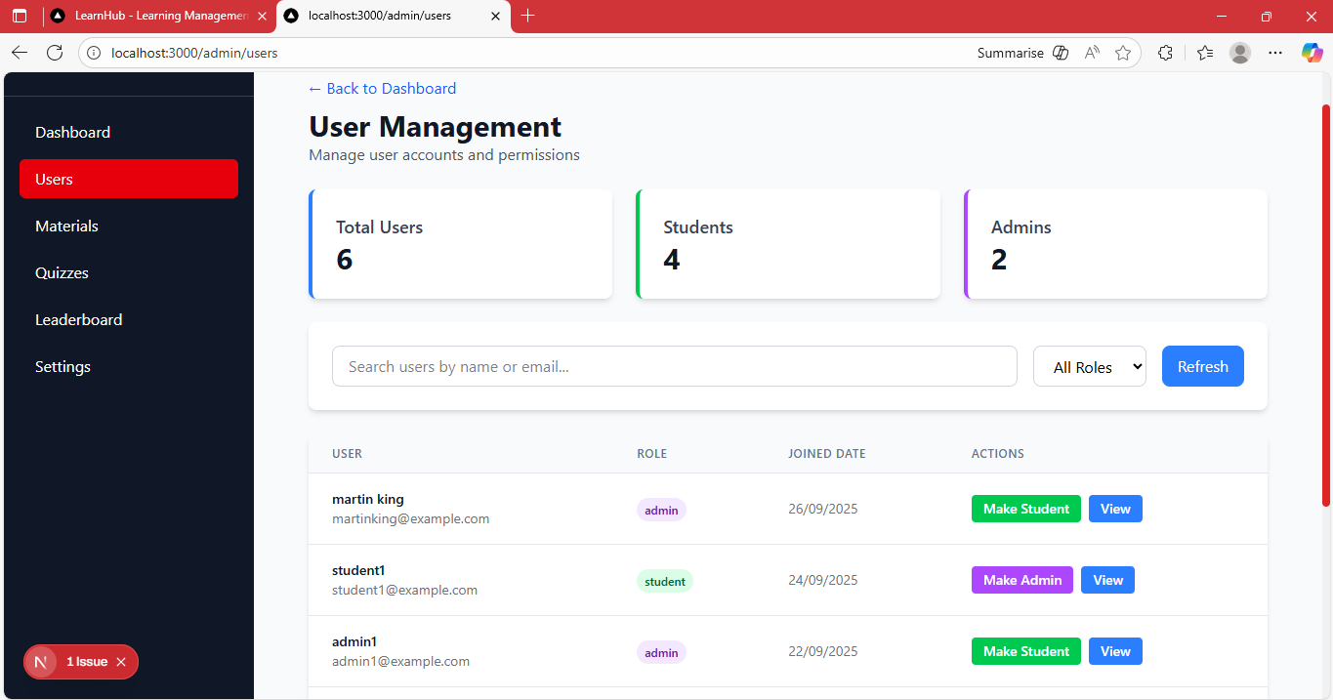

Figure 4.5: User management page (admin)

The “User management page” shows a full list of all registered users on the system. It shows their activities and administrators can change the role of users on this page.

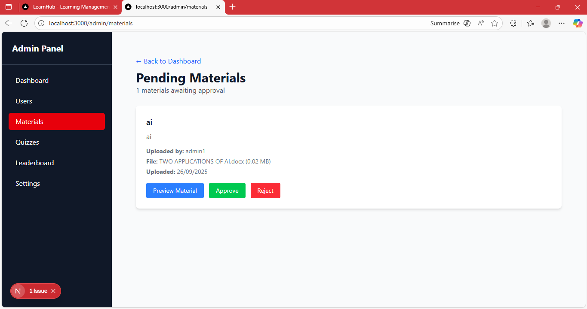

Figure 4.6: Pending Materials page (admin)

The “Pending Materials page” shows a full list of all materials awaiting approval. Administrators can preview the file and then approve or reject it.

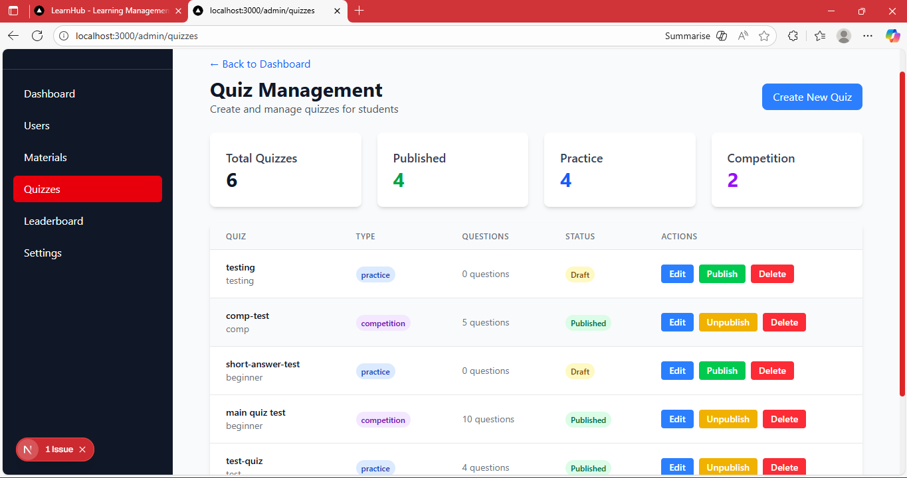

Figure 4.7: Quiz management page (admin)

The “Quiz management page” shows a full list of all existing quizzes on the system. On this page, administrators can create,edit, and publish quizzes.

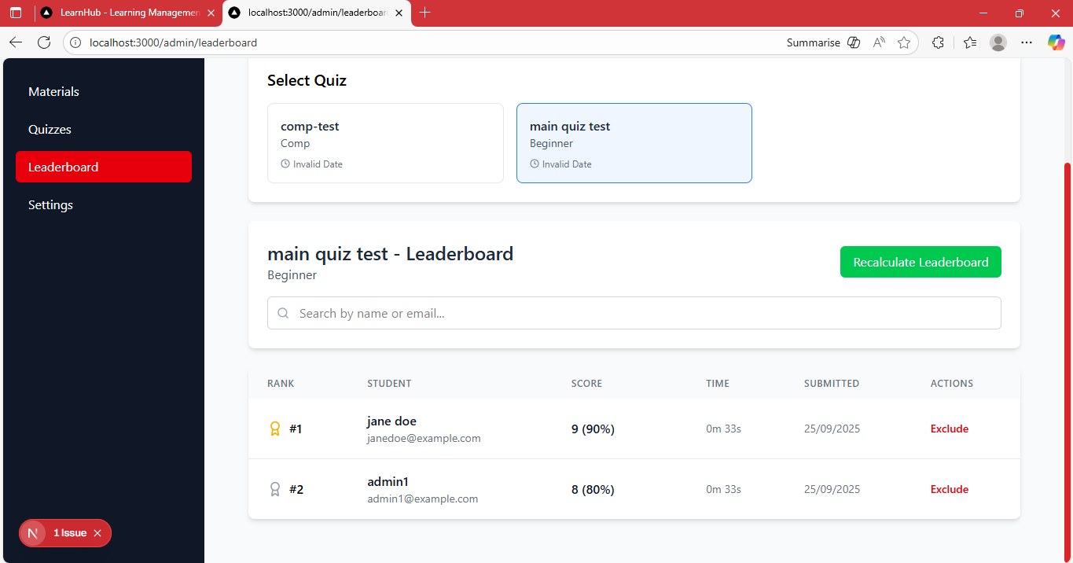

Figure 4.8: Leaderboard management page (admin)

The “Leaderboard management page” shows the leaderboard for competition quizzes.



Figure 4.10: View Materials page (student)

The “View Materials page” provides an interface for students to see all the materials on the system. It provides a search feature and a filter. Materials can be filtered by course, category, and level.

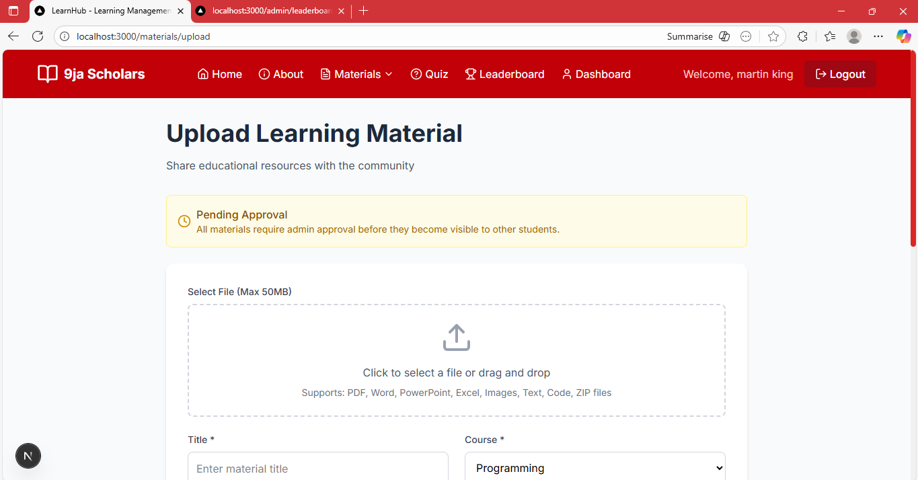

Figure 4.11: Upload Materials page (student)

The “Upload Materials page” provides an interface for students to upload academic material. The uploaded material cannot be seen unless approved by an administrator.



Figure 4.12: Available Quizzes page (student)

The “Available Quizzes page” shows all the available quizzes to the student. They can filter the quizzes to get either practice, competition, or all quizzes.

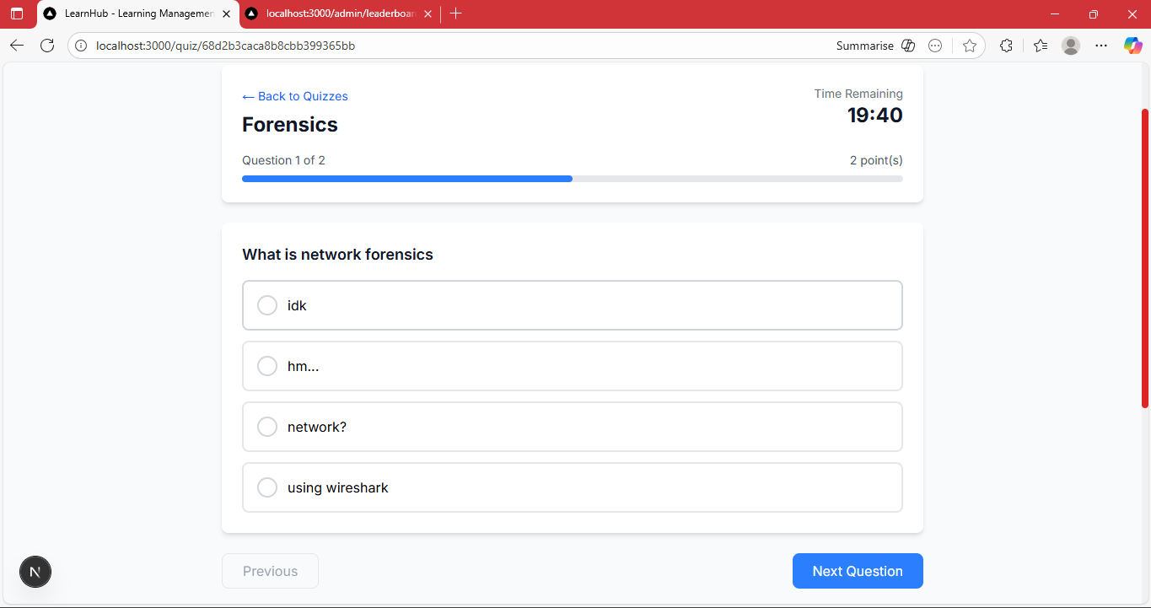

Figure 4.13: Quiz taking page (student)

The “Quiz taking page” provides an interface for students to take quizzes. There’s a timer, progress tracker bar, previous question button, next question button, and submit button for easy navigation.

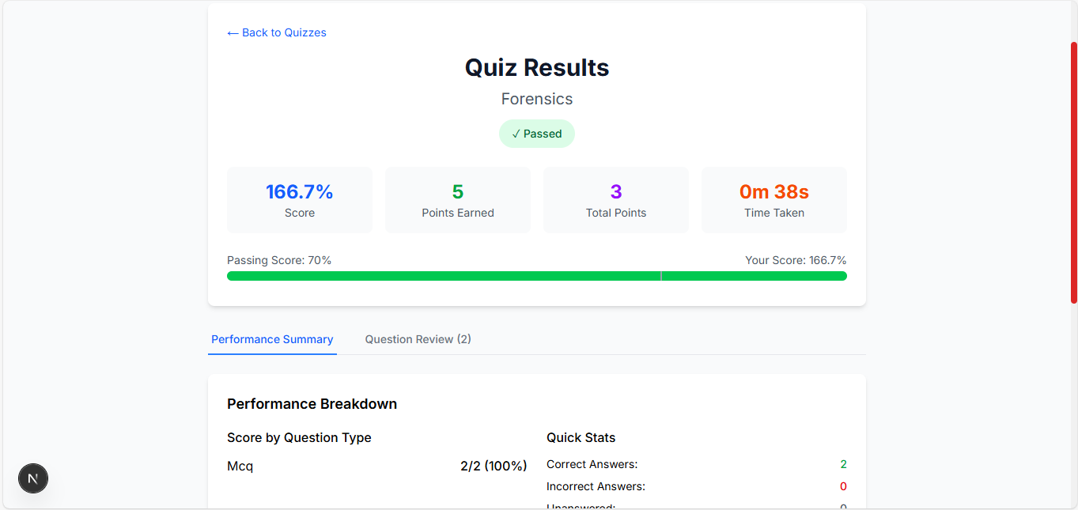

Figure 4.14: Quiz results page (student)

The “Quiz results page” shows the student their score, time taken, and performance summary immediately after submitting the quiz.

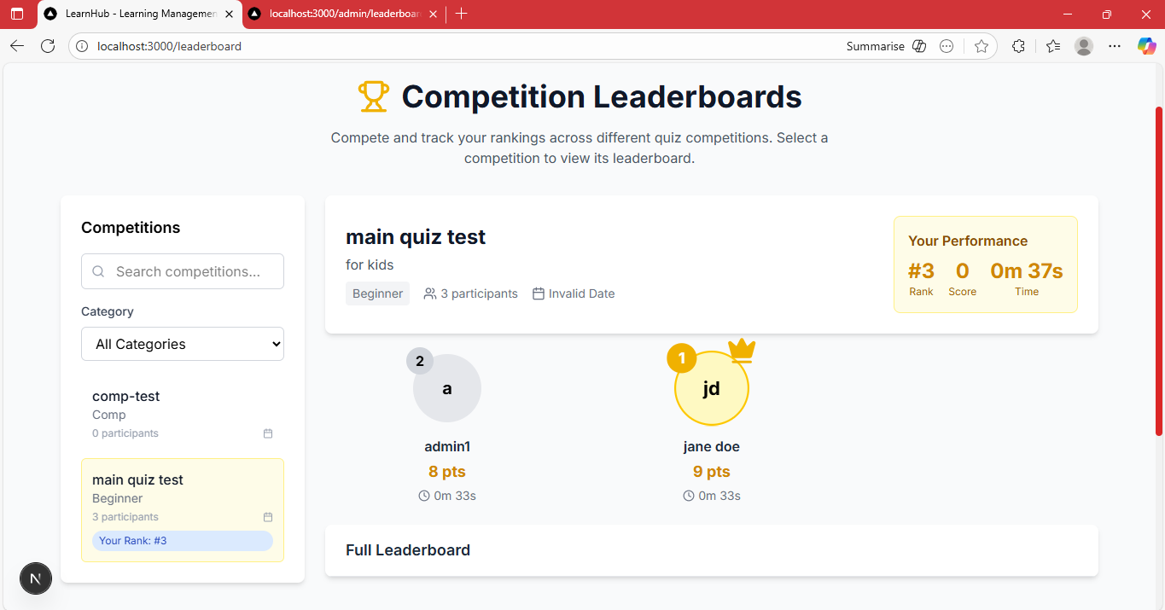

Figure 4.15: Leaderboard page (student)

The “Leaderboard page” shows the leaderboard for any competition quiz. Students can see how they performed compared to others. The top three podium displays the students with the top three highest scores.



Figure 4.16: Student dashboard

The “Student Dashboard” displays the students information and provides a summary of their activities on the application.

**4.8 Summary**

The implementation of the collaborative learning system was successful and met all the requirements. The tests showed that the application performs as expected and is usable. The user guide will assist users in navigating the system effectively. The next chapter covers an assessment of the project, limitations, summary, and any recommendations for the future.

**CHAPTER 5**

**DISCUSSION, CONCLUSION, AND RECOMMENDATIONS**

* 1. **Overview**

This chapter provides a comprehensive discussion on Collaborative Academic Platform with Inter-University Leader board Competitions. It evaluates the objectives of the project, the challenges faced during development, and future enhancements.

**5.2 Objective Assessment**

The objectives set for for the system at the early development stage include:

1. To create a user interface where computer science students across Nigerian universities can share and access academic materials.
2. To implement a quiz creating module for making quizzes and academic competitions that students can participate in.
3. To provide an efficient user management system that allows administrators to oversee student activities, monitor their performance, and evaluate engagement for continuous platform improvement.
4. To implement a leaderboard ranking system for academic competitions across institutions.

The platform's primary objective, which was to provide computer science with a space to share knowledge and test themselves against one another, has successfully been achieved through assessment.

* 1. **Limitations and challenges**

The implementation phase proved successful, but there were several limitations and challenges encountered during the development process:

1. Scalability Concerns: As the number of users on the system increases, making sure that it still performs quickly becomes a critical concern.
2. Time constraint: The application was built within a limited timeframe. This caused certain minor features to be eliminated even though the objectives were achieved.
3. New technologies: Learning the technologies I used for the development posed a great challenge for me.
   1. **Future Enhancement**

1. Mobile Application: develop a mobile application (Android/iOS) to allow students to take quizzes, upload materials, and view their rank.

2. Essay and Subjective questions: quizzes will include short answer and long answer questions that will be manually graded by administrators.

3. More Gamification mechanics: in addition to leaderboards, introducing badges will motivate students to participate actively during learning.

4. Notification system: email or in-app notification to alert users on available quizzes, leaderboard updates, achievements, and admin announcements will be very useful.

5. Offline support: students can attempt quizzes offline, and results can sync when they come online.

# 

# 

# REFERENCES

Adeoye, M. A. (2023). Influence of gamification elements on students' academic performance. *Indonesian Journal of Teaching in Science*, *3*(2), 105–112. https://doi.org/10.17509/ijotis.v3i2.59581

Anyanwu, J. (2023). Public examinations in Nigeria: Challenges and prospects in the 21st century. *Global Academic Journal of Humanities and Social Sciences*, *5*(1), 10–15. https://doi.org/10.36348/gajhss.2023.v05i01.003

Badmus, O. (2021). *The new face of the ULesson app* [Blog post]. ULesson. https://ulesson.com/blog/the-new-face-of-the-ulesson-app/

Balogun, S. (n.d.). Gamified learning as a strategic tool for addressing differentiated instruction challenges in Nigerian tertiary English classrooms. *Journal of Education, Communication, and Digital Humanities*, 32–42. https://doi.org/10.5281/zenodo.15824204

Boud, D., & Bearman, M. (2022). The assessment challenge of social and collaborative learning in higher education. *Educational Philosophy and Theory*. https://doi.org/10.1080/00131857.2022.2114346

Buoye, P., & Bada, O. (2021). Analysis of the effect of computer based examination introduced by JAMB. *International Journal of Women in Technical Education and Employment*, *2*(2), 63–72. https://fpiwitedjournal.federalpolyilaro.edu.ng

Chen, Z., Jiao, J., & Hu, K. (2021). Formative assessment as an online instruction intervention: Student engagement, outcomes, and perceptions. *International Journal of Distance Education Technologies*, *19*(1), 1–20. https://doi.org/10.4018/IJDET.20210101.oa1

*Collaborative learning* (n.d.). The University of Queensland Australia. https://itali.uq.edu.au/teaching-guidance/teaching-practices/active-learning/collaborative-learning

Daramola, F. O., & Aladesusi, G. A. (2022). Information communication technology as a tool for improving Nigerian education at all levels: A theoretical perspective. *Indonesian Journal of Educational Research and Review*, *5*(1), 131–138. https://doi.org/10.23887/ijerr.v5i1

Ebohon, O., Obienu, A. C., Irabor, F., Amadin, F. I., & Omoregie, E. S. (2021). Evaluating the impact of COVID-19 pandemic lockdown on education in Nigeria: Insights from teachers and students on virtual/online learning. *Bulletin of the National Research Centre*, *45*(1), Article 76. https://doi.org/10.1186/s42269-021-00538-6

Evgeniou, A. (2022, August 10). History of education in Nigeria. *Unicaf*. https://www.unicaf.org/history-of-education-in-nigeria/

Fobuike, J. C. (2025). A critique of the colonial underpinnings of Nigerian education policies. *Journal of Philosophy, Policy and Strategic Studies*, *2*.

Hart, P. F., & Rodgers, W. (2024). Competition, competitiveness, and competitive advantage in higher education institutions: A systematic literature review. *Studies in Higher Education*, *49*(11), 2153–2177. https://doi.org/10.1080/03075079.2023.2293926

Herrera-Pavo, M. A. (2021). Collaborative learning for virtual higher education. *Learning, Culture and Social Interaction*, *28*, Article 100437. https://doi.org/10.1016/j.lcsi.2020.100437

Hu, J. (2024). The challenge of traditional teaching approach: A study on the path to improve classroom teaching effectiveness based on secondary school students' psychology. *Lecture Notes in Education Psychology and Public Media*, *50*, 213–219.

Ibrahim, A.-W., Taura, A. A., Iliyasu, A., & Rabiu, A. U. (2023). Digitalising educational assessments in a Nigerian university: An examination of undergraduate students' digital behaviours and experiences. *Journal of Teaching and Teacher Education*, *11*(2), 47–56. https://doi.org/10.12785/jtte/110202

Igbo, H. U., Ibegbulam, I. J., Asogwa, B. E., & Imo, N. T. (2022). Provision of digital information resources in Nigerian university libraries. *Information Research*, *27*(3), Article 936. https://doi.org/10.47989/irpaper936

Iji-Okeke, N. M., & Okeke, F. A. (n.d.). A linguistic analysis of students' engagement in English language classrooms through gamification and virtual reality. *ANSU Journal of Language and Literary Studies*, *5*(1), 37–51.

James, J. (2022). *Perception, attitude and satisfaction of undergraduate students on e-assessment of universities in Niger State, Nigeria* [Master's thesis, Federal University of Technology Minna].

Kapp, K. M. (2012). *The gamification of learning and instruction: Game-based methods and strategies for training and education*. John Wiley & Sons.

Kerman, N. T., Banihashem, S. K., & Noroozi, O. (2023). The relationship among students' attitude towards peer feedback, peer feedback performance, and uptake. In O. Noroozi & B. De Wever (Eds.), *The power of peer learning: Fostering students' learning processes and outcomes* (pp. 347–372). Springer. https://doi.org/10.1007/978-3-031-29411-2_16

Lampropoulos, G., & Sidiropoulos, A. (2024). Impact of gamification on students' learning outcomes and academic performance: A longitudinal study comparing online, traditional, and gamified learning. *Education Sciences*, *14*(4), Article 367. https://doi.org/10.3390/educsci14040367

Lipponen, L. (2023). Exploring foundations for computer-supported collaborative learning. In O. Noroozi & B. De Wever (Eds.), *The power of peer learning: Fostering students' learning processes and outcomes*. Springer.

Mahlangu, G., & Makwasha, L. (2023). Factors affecting the adoption and use of online assessment for learning at polytechnics in Zimbabwe. *Cogent Education*, *10*(1), Article 2177475. https://doi.org/10.1080/2331186X.2023.2177475

Morris, R., Perry, T., & Wardle, L. (2021). Formative assessment and feedback for learning in higher education: A systematic review. *Review of Education*, *9*(3), Article e3292. https://doi.org/10.1002/rev3.3292

Garba, M. M. (2023). The challenges of access to university education in Nigeria. https://doi.org/10.15242/ICEHM.ED1214104

Nikitin, V. (2024, April 16). Software development methodologies: types, selection criteria & stats. *Itransition*. https://www.itransition.com/software-development/methodologies

Nnonyelu, N. A., & Onyeizugbe, C. U. (2020). Reimagining Igbo apprenticeship: Bringing it up to speed with contemporary realities. *European Journal of Business and Management Research*, *5*(3), 1–8. https://doi.org/10.24018/ejbmr.2020.5.3.327

Nwachukwu, U. M., & Johnson, P. A. (2020). Effect of gamification on performance and interest of students in basic technology in Rivers state. *International Journal of Innovative Information Systems and Technology Research*, *8*(2), 26–36.

Ogunlola, L. (2020). The pre-colonial Yoruba education system: Catalyst against immorality. *YSR*, *5*(1), 83–97.

Okekeokosisi, J. O. C., Bamisebi, O. A., & Okoh, F. J. (2025). Effectiveness of gamified-based-activity on Nigeria colleges of education students' achievement in number system. *Journal of Science Education and Research*, *2*, 45–58.

Okparaugo, O. J., Yusuf, A., & Nasiru, Z. (2021, March). *A critique of the 1960 curriculum review emphasizing on the highlights that stimulated national development* [Seminar paper]. Federal University, Dutsin-Ma, Katsina State, Nigeria.

Olugbade, D., Dare, R. F., & Tolorunleke, E. A. (2023). Examining the impact of interactive smart board use on technical students' learning outcomes in Nigerian higher educational institutions. *Journal of Education in Black Sea Region*, *8*(2), 30–38.

Oshodi, I. K. (2022). A review of the impact of education technology in developing countries (A case study of Nigeria). *ResearchGate*. https://doi.org/10.13140/RG.2.2.10596.30084

Özyer, K. K. (2024). Online assessment in Turkish universities: Challenges, strategies, and self-efficacy dynamics. *Journal of Social Studies Education Research*, *15*(1), 1–37.

Patel, R. (2024, October 4). A beginner's guide to Entity Framework Core (EF Core). *Medium*. https://medium.com/@ravipatel.it/a-beginners-guide-to-entity-framework-core-ef-core-5cde48fc7f7a

Patil, H., Tripathi, L., Sahu, M., Sharma, J. C., Sharma, G., & Quraishi, S. (2024). Integrating technology and innovation for effective educational management and equitable learning in Nigeria. *African Journal of Biological Sciences*, *6*(7), 4029–4037. https://doi.org/10.48047/AFJBS.6.7.2024.4029-4037

Qureshi, M. A., Khaskheli, A., Qureshi, J. A., Raza, S. A., & Yousufi, S. Q. (2021). Factors affecting students' learning performance through collaborative learning and engagement. *Interactive Learning Environments*. https://doi.org/10.1080/10494820.2021.1884886

Rani, M., Arif, K. M., Ishaq, A., & Abbas, F. (2023). Role of information communication technology in education: An overview. *Qualitative Research*, *23*(2), 160–173. https://www.researchgate.net/publication/374386493

Sabornido, E. B., Garma, V. A., Niepes, G. L., & Cabria, F. M. N. (2022). Key challenges and barriers in gamification: A systematic review. *Asia Pacific Journal of Advanced Education and Technology*, *1*(1), 13–20.

Shalatska, H. M., Zotova-Sadylo, O. Y., Makarenko, O. Y., & Dzevytska, L. S. (2020). Implementation of e-assessment in higher education. In *Proceedings of the 2nd International Workshop on Intelligent Information Technologies and Systems of Information Security* (pp. 1–13). CEUR-WS.org.

Simelane, R. M., & Pillay, P. (2024). The evolution of assessment methods in higher education due to the shift to remote learning: A case study. *Research in Educational Policy and Management*, *6*(2), 393–414. https://doi.org/10.46303/repam.2024.41

Sridharan, B., McKay, J., & Boud, D. (2023). The four pillars of peer assessment for collaborative teamwork in higher education. In O. Noroozi & B. De Wever (Eds.), *The power of peer learning: Fostering students' learning processes and outcomes* (pp. 3–24). Springer. https://doi.org/10.1007/978-3-031-29411-2_1

Tolorunleke, E. A., Haruna, M. M., & Olugbade, D. (2023). Influence of tertiary students' usage of online collaborative tools for learning and improving students' academic performance in Kogi State, Nigeria. *Journal of Science, Technology and Mathematics Pedagogy*, *1*(1).

Topping, K. J. (2023). Advantages and disadvantages of online and face-to-face peer learning in higher education: A review. *Education Sciences*, *13*(4), Article 326. https://doi.org/10.3390/educsci13040326

Tshukudu, E., Sentance, S., Adelakun-Adeyemo, O., Nyaringita, B., Quille, K., & Zhong, Z. (2023). Investigating K-12 computing education in four African countries (Botswana, Kenya, Nigeria, and Uganda). *ACM Transactions on Computing Education*, *23*(1), Article 9. https://doi.org/10.1145/3554924

Udeani, U. N., & Akhigbe, J. N. (2020). Gamification as an instructional approach under collaborative and competitive modes: An analysis of students learning outcomes in biology. *International Journal of Innovative Technology Integration in Education*, *4*(1), 42–60.

Umuerhi, F. J., & Urhiewhu, L. O. (2023). Jumping the gun: Relevance of past questions paper. *Library Progress International*, *43*(1), 39–45. https://doi.org/10.48165/bpas.2023.43.1.5

Yusof, R., Corridor, K. Y., Norwani, N. M., Ahmad, N. L., & Ismail, Z. (2022). Investigating the role of digital learning in enhancing educational values: Online socialization and its effect on peer learning, collaborative skills and knowledge construction. *International Journal of Learning, Teaching and Educational Research*, *21*(9), 441–459. https://doi.org/10.26803/ijlter.21.9.24

Zeng, J., Sun, D., Looi, C.-K., & Fan, A. C. W. (2024). Exploring the impact of gamification on students' academic performance: A comprehensive meta-analysis of studies from the year 2008 to 2023. *British Journal of Educational Technology*, *55*, 2478–2502. https://doi.org/10.1111/bjet.13471

**APPENDICES**

Appendix A: Questionnaire

Surveys were sent out to Nigerian students across Nigerian Universities, and it included the following questions:

1. What university are you currently enrolled in?
2. What department and level are you in?
3. Gender

* Male
* Female
* Non-binary
* Other
* Prefer not to say

1. How do you usually get past questions or lecture notes?

* Friends
* Whatsapp groups
* School library

1. Do you think there's enough access to reliable academic materials in your school?

* Yes
* No
* Not Sure

1. Have you ever missed important content (past questions, notes) because you didn’t know where to find it?

* Yes
* No
* Sometimes

1. Do you currently belong to any academic study group?

* Yes
* No

1. Would you join a study group with students from other universities if it helped you perform better?

* Yes
* No
* Maybe

1. How do you normally prepare for exams?

* Solo study
* Study groups
* Using past questions
* Watching online tutorials

1. Would you find a platform helpful where students from any school can share past questions and lecture notes ?
2. Would you find a platform helpful where students from any school can discuss course topics and ask questions
3. Would you find a platform helpful where students from any school can take quizzes and enter challenges and be ranked
4. Would you be willing to use such a platform regularly
5. Which feature would be most important to you?

* Access to materials
* Discussion forums
* Quizzes and leaderboards
* Study groups

1. What challenges do you think may stop students from using such a platform?
2. What would encourage you to use it more often?